|  |  |
| --- | --- |
| faro logomed | Application Method Sheet Multiple Trackers and/or Arms used in Combination  Using Multiple Devices - CAM2 Q |
|  | |

**Application Description**

The process that will be described in this method sheet is integrating more than one measurement device into a single measurement file. The steps to do this will be outlined and some examples given as to why this would be useful. After reading this sheet the user will be able to run multiple devises (two arms, two trackers, one arm & one tracker, or more devices in combination) within the same measurement file and alignment.

**Setup**

* Software
  + Open a new Cam2 Q file
  + An alignment is not needed; however, establish the alignment as the normal workflow process dictates if required.
  + You will need a minimum of 3 point-reducible features. Ex: circles, spheres, points, etc. Note (tracker and arm): if using comp off points, the radius of the probe must be the same radius as the SMR in order for ball center to be at the same location.
  + There are 2 different ways to set up the measure file; one is the arm as the primary device and the other is the tracker. Below is a list of hardware items needed for each scenario.
    - Tracker as primary: The easiest way is to glue down 3 or more of the tracker pucks for the 1.5 SMR. NOTE: These must be reachable by the arm as well as the tracker.
    - Arm as primary: Spheres and circles are usually the easiest to use. Uncompensated points (or comp off points) can be a problem as the SMR and arm probe will most likely have different center points or diameters. NOTE: Measure features that the tracker can get to. Keep line of sight for the tracker in mind.
* Hardware
  + Multiple Devices
    - Two or more arms
    - Two or more trackers
    - Three or more devices in any combination
  + Optional reference items needed. NOTE: not all of these items are needed at once. Circles and spheres can always be used.
    - 3 or more tracker pucks
    - 3 or more reference cones
    - 3 or more reference spheres

**Configuration**

* Open Cam2 Q software
* With the primary device connected, as determines above in the software setup section, measure at least 3 point reducible features using circles, spheres, or optional reference items.
* Connect the next measurement device to the software.
  + Check Faro Device Control Panel to verify that the equipment is being recognized by the software. (Device>Device Control Panel)
  + Verify the connected device(s) in the list. EX: One arm and one tracker.

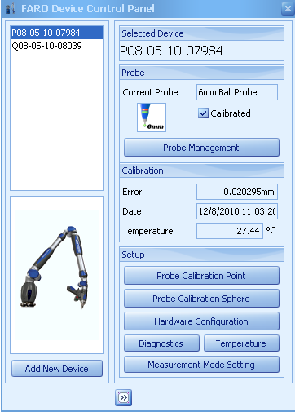

* Go to Device > Device Manager
  + There will be two devices and two device positions listed.

Note: When devices connected, Serial Numbers will show instead of “New Device”

* If not visible, click “Add” to add the second device.

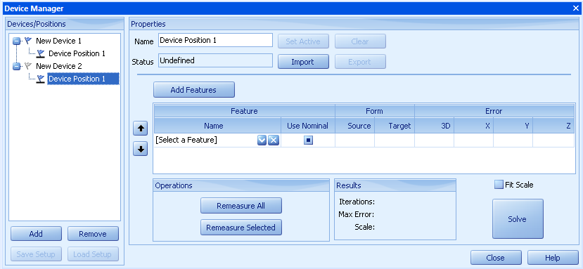

* + Click on Device Position 1 for the second device (New Device 2).



* + Highlight the point features measured in the feature tree.

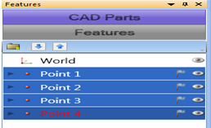

* In the Device Position window click “Add Features” button
  + The point reducible features will then be placed in the list.

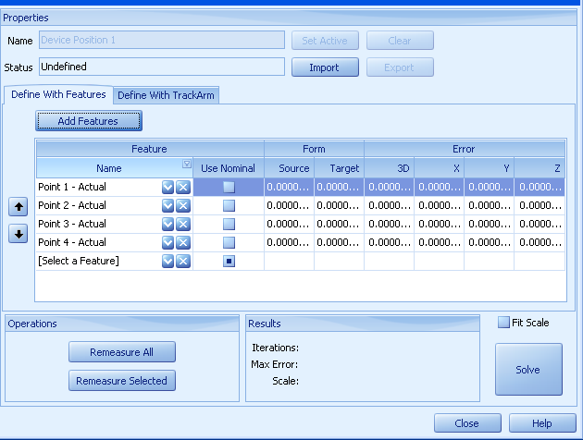

**Feature List**

* Now click the “Remeasure All” button.
* You will need to re-measure all these features, with the newly added device, in the order requested.



NOTE: This process will align the features measured from the first device to those measured with second device. If the previous measurements are already aligned to CAD with the first device, selecting “Use Nominal” check boxes next to each feature will align the features measured from the second device to the associated nominal feature from the first. This can provide for a more accurate alignment of the additional devices.

* Once the features have been re-measured, click on the “Solve” button.
  + - Just above the Solve button is a check box for “Fit Scale”. This will scale the measured features to their associated features during the best fit process. This adjusts for changes in the relative distances mostly due to temperature changes.
* After clicking solve, view the Results box.
  + - If there is a high 3D error for a particular feature(s) or a high Max Error, there are a few options to reduce this error.
    - A – If using more than 3 point reducible features remove the feature with the highest 3D error from the list and solve again. Click on the 3D error header to sort the data.
    - B – Select the feature with the highest error, highlight it, and click “Remeasure Selected”. Remeasure the feature. Click Solve again and review the Results box.
    - C – Click Remeasure All again and then re-solve.

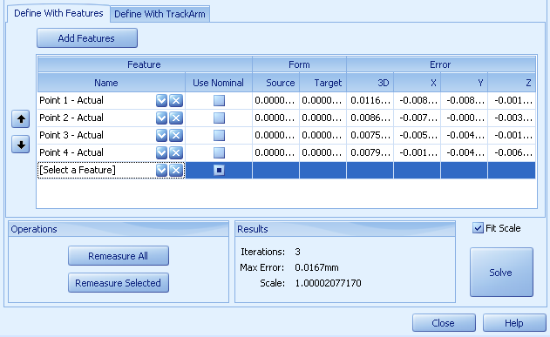

**3D Error**

**Remove feature**

* Close Device Manager. The Cam2 Q file with now have both devices in the same alignment.

**Measurement**

This file is now aligned to both devices. The software will allow measuring features using either device. What this means is readings can be taken, for each unique feature, using either device. The first device will default as the “Root” and will be the device that is used if no specific device is selected.

* When using multiple devices is it best to set up the measurement session by selecting the features using Template mode.
* Once all features have been added, right click on that feature. There will be a designation allowing the operator to select the device to take measurements from. This is “Add Readings From”.

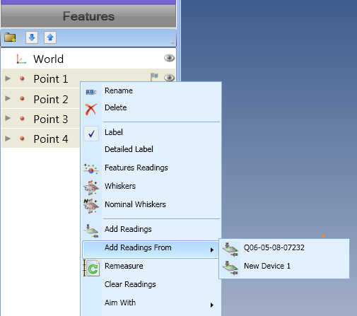

**Select Device**

**Applications**

There are several reasons why multiple devices would be beneficial for measuring features on a part.

1. Using both the FaroArm and Tracker. The part that needs to be measured is large in volume but have some aspects that are detailed and hard to get to. The FaroArm allows measuring detailed aspects of a part all while not having to worry about line of sight needed for the tracker. The tracker allows measuring large volume aspects of the part or great distance from the Arm so that there is no need to move the arm to accomplish the measurements.
2. There are multiple devices that can be utilized. If there is a big job will a lot of things that need to be checked, using multiple devices will allow more than one operator to measure the part at the same time. This can drastically reduce the measurement time.
3. If measuring parts that are have line of sight issues (tracker), the use of multiple devices will limit the need to move the tracker devices and incur higher errors.

**Reporting**

The readings tab for each feature will show all the points taken and by what device the points were taken with. Now a report can be generate as normal.

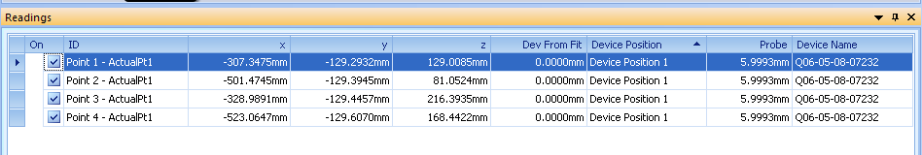

**Device Used to take point**

**For questions and concerns please email FARO Customer Service:**

Faro Technologies Inc.                           FARO EUROPE GmbH & Co. KG FARO Singapore Pte. Ltd

250 Technology Park                              Lingwiesenstr. 11/2 · 70825                                     3 Changi South Street 2,

Lake Mary, FL 32746                              Korntal-Münchingen · Germany                               486548 Singapore

1-800-736-2771 +49.7150.97.97-400 1800-511-1360

[**support@faro.com**](mailto:support@faroeurope.com) [**support@faroeurope.com**](mailto:support@faroeurope.com) [**supportAP@faro.com**](mailto:supportAP@faro.com)

**Disclaimer:** *Faro Technologies, Inc. makes no warranty, express, implied or statutory, as to the material on this form, including any referenced third party. The material contained on this form is for informational purposes only; such material is provided “AS IS” and with all faults, and your use of the material is at your own risk.*