|  |  |
| --- | --- |
| faro logomed | Application Method Sheet Move Device Method Sheet for CAM2 Q v1.5  Move Device using Circles |
|  | |

**Application Description**

Move device, or leap frog, is a command used in Cam2 Q to realign or tie previously measured data back to the measurement device to continue to use the desired working coordinate system. The move device function may need to be preformed due to two major factors. They are a planned move and an unexpected movement of the part or device. If the part being measured is larger than the arms reach or out of the line of sight of the tracker a planned move device may need to be preformed. Accidental movement of the part or device is examples of an unexpected need for a move device. This method sheet will use circles as the point reducible features for the move device command.

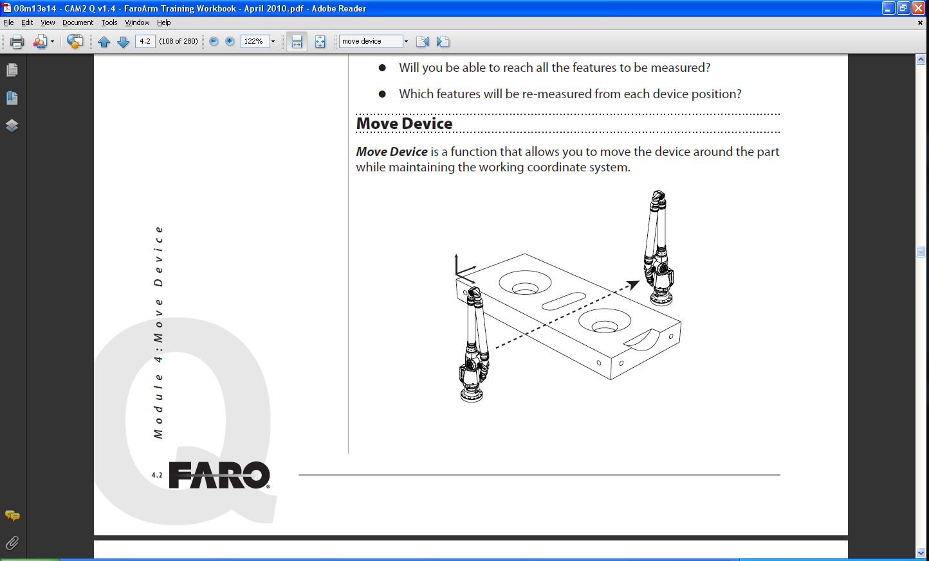

There are several considerations that need to be made in order to correctly perform a move device.

* The first is that a minimum of three (3) circles have been measured prior to the move device command. The more circles measured the better representation of the surface you will have. Also, the additional circles will later allow for reduction in the move device error incurred.
* Circles are to be spread out over the part as much as possible but still be able to be measured from two (2) locations. The first location is the original measured location and the second is the new position or desired location.
* The circles should encompass as large of the area of the part that can be measured from each location.
* Circles should not all on the same plane or in a straight line.

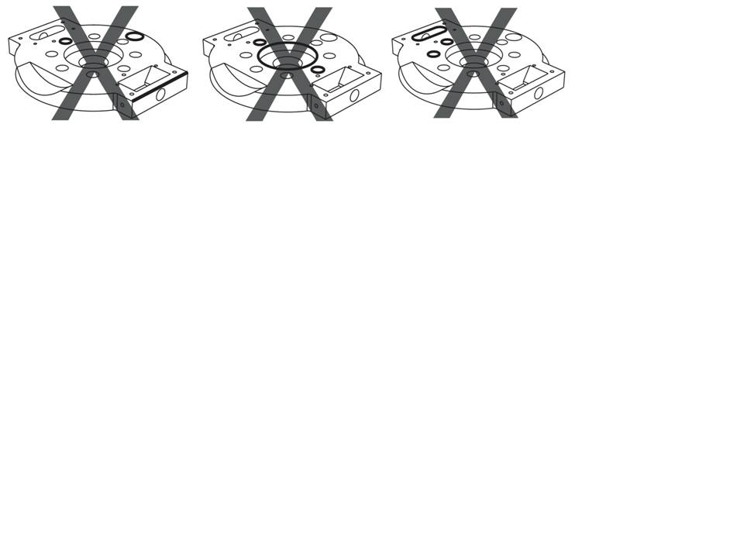

* Measure five plus (5+) circles. Although the command requires only three (3), the error from the 5+ circles can be sorted and the circles providing the highest error can be eliminated from the calculation. If only three (3) circles are measured, the error cannot be reduced.
* Set up the circles as soon as possible. After an alignment is established is sufficient. Measure the circles whether a move device is planned or not. An accidental movement of the part or device can happen at any time. This can come from a forklift, overhead crane, or an accidental trip over the tripod or table support the device.
* Minimize the number of moves in one direction to reduce stackable error. If multiple move device commands are planned, use a central location for the starting point to move outward from in one direction. If another direction needs to be measured, the move device command can be used to tie back into the measurement file from the central location. To do this place the device in the new location, along the other direction, where it can measure at least three (3) circles measured from the original location.

**Setup**

* Software
  + Minimum of three (3) circles measured before the command can be preformed.
* Hardware
  + Make sure all the circles can be measured from both the original location and the new desired location.
  + If multiple move device commands are needed, start from a central location and move outward.

**Part Alignment and Setup**

* An alignment does not need to be established in order to perform a move device
* The device and part setup should be stable and sturdy to ensure no movement or change in relationship of the device to the part. This follows normal measurement procedures when using the Faro equipment.
* After physically moving the device (or part) re-secure the device and part to ensure proper measurements moving.

**Measurement**

* Measure the required circles. This method sheets assumes all circles are on the same plane projection.

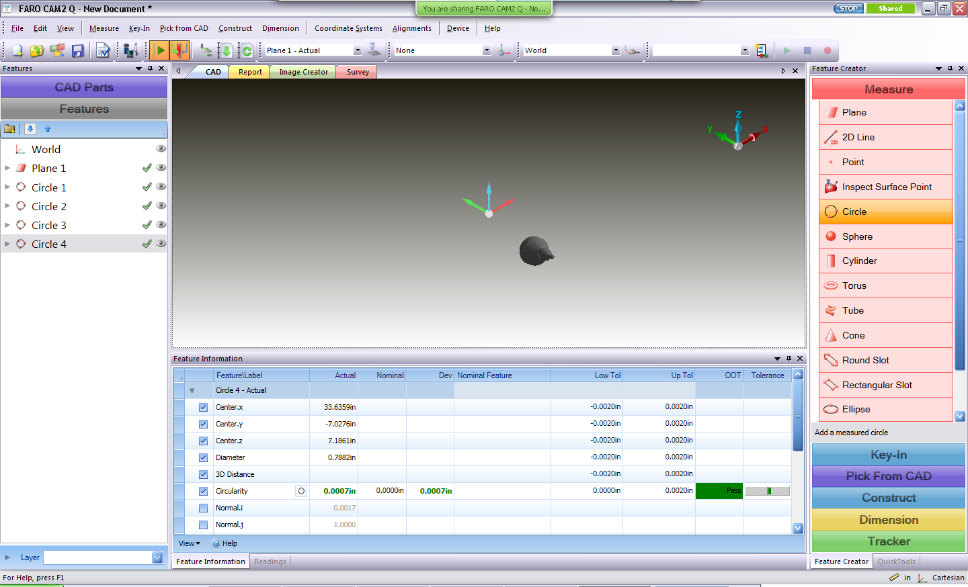

* When ready to perform the move device command go to device>move device (or use the hot key M)

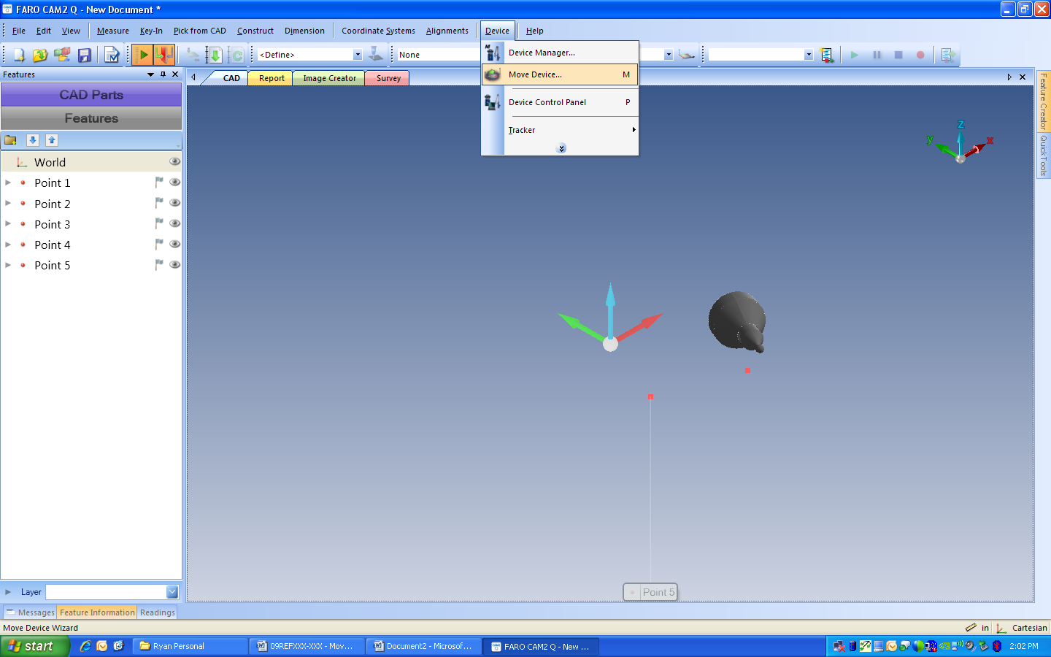

* Once the device manager dialogue box appears, add the circles to be re-measured
  + The circles can be highlighted from the feature tree, while on the new desired device position, and then hit “Add Features”

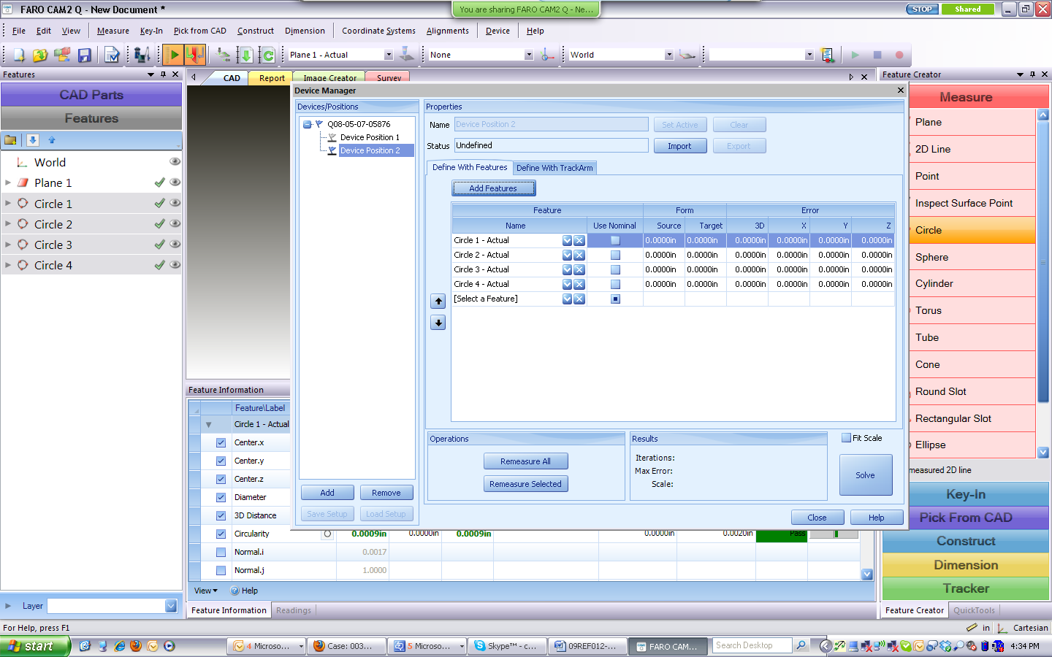

* + The circles can also be added by again having the new device position selected and then hit the down arrow. Manually add each feature

Circles added to the move device routine:

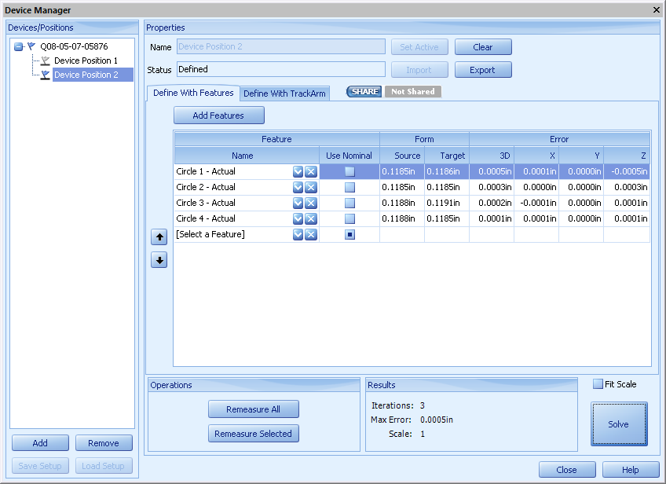

* Physically move the device or part
* Select “Remeasure All”
* Remeasure each feature using the Faro device.
* Select “Solve”

Special Notes:

The order the circles are listed is important. This determines the order the circles are remeasured. The up and down arrows can be used to reorder them. Pay close attention to the measurement box as to what feature it is asking to be remeasured.

Fit Scale can also be added to automatically compensate for temperature difference by selecting the check box.

**Review Results**

After the circles are remeasured and solved for the new device position, the Results portion of the Device Manager will display several important pieces of information. They are Iterations, Max Error, and Scale.

* Iterations – the number of times the software tried to best fit the previously measured features with the newly measured ones. The number of iterations is not an important factor in the calculation of the device move error or how effective the command preformed
* Max Error – the maximum error calculated by the software by best fitting the features together. If this number is extremely high, the most likely reason is the features were measured in the incorrect order.
* Scale – the temperature scaling factor
* Results Box without removing any circles:

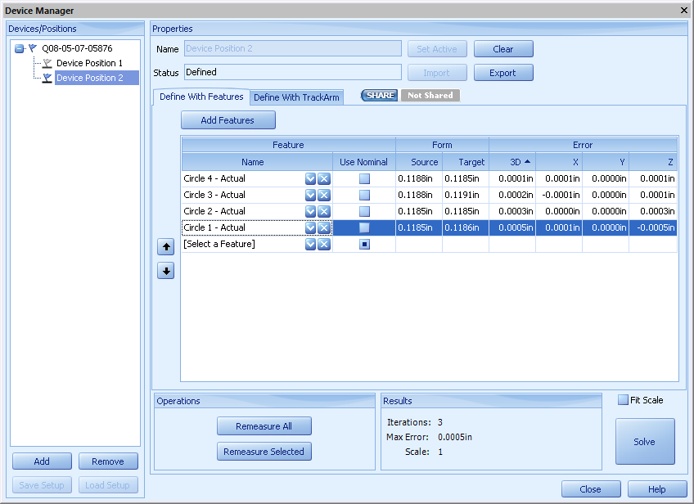

If the error is higher than desired or better results would like to be obtained, circles can be removed from the calculation to improve the move device command.

* After the first move device is calculated, the error is now populated in the feature information. To improve overall error, sort the column by 3D error. The feature with the highest error can be removed by hitting the “X” next to the feature name.



* Hit Solve again and then review the results and max error. This can be preformed until there are only three (3) circles left. This is why Faro recommends using more than 3 circles.
* Results Box with removing all but three (3) circles. In this example, the error was reduced to 0:

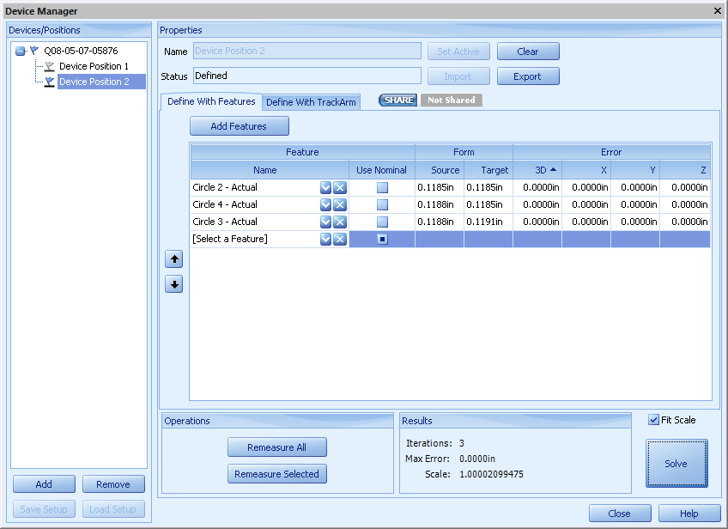

**Conclusion**

Move device command can be used in order to realign or tie back into a previously established working coordinate system. A move device can be performed as part of a planned measurement session (part too large or line of sight for the Laser Tracker), multiple measurement sessions over time, or an accidental change in the device to part relationship. Once the move device has been performed, measuring the part can continue. All of the data captured moving forward will be in the same measurement file and in the same relationship as established the first device position.

**For questions and concerns please email FARO Customer Service:**

Faro Technologies Inc.                           FARO EUROPE GmbH & Co. KG FARO Singapore Pte. Ltd

250 Technology Park                              Lingwiesenstr. 11/2 · 70825                                     3 Changi South Street 2,

Lake Mary, FL 32746                              Korntal-Münchingen · Germany                               486548 Singapore

1-800-736-2771 +49.7150.97.97-400 1800-511-1360

[**support@faro.com**](mailto:support@faroeurope.com) [**support@faroeurope.com**](mailto:support@faroeurope.com) [**supportAP@faro.com**](mailto:supportAP@faro.com)

**Disclaimer:** *Faro Technologies, Inc. makes no warranty, express, implied or statutory, as to the material on this form, including any referenced third party. The material contained on this form is for informational purposes only; such material is provided “AS IS” and with all faults, and your use of the material is at your own risk.*