 | Application Method Sheet  Setting up Survey command in CAM2 Q v1.3 :  Survey Command being run to check periodic measurements
Survey Command to check periodic measurements
For a general application where a fixture or assembly is to be measured over a specified amount of time or periodic intervals. This can be done with nominal data or without. This automation is used to check the change in pre-established points after there has been movement or time lapse. (EX: Establish 4 points on a closed door; open and close the door and those points should still be in the same position. The Survey will help automate that process.) If you are using nominal data then you will want to align. You will also want to make sure that you have enough SMR’s to match the number of points you want to survey.

1. In CAM2Q, create your Coordinate System and CAD to Part Alignment as normal.

2. Using SMR’s and target pucks establish one or more points you want to track by using the Measure -> Point (un-compensated point) feature.

3. If you are checking to a nominal make sure that they are associated to the proper points.

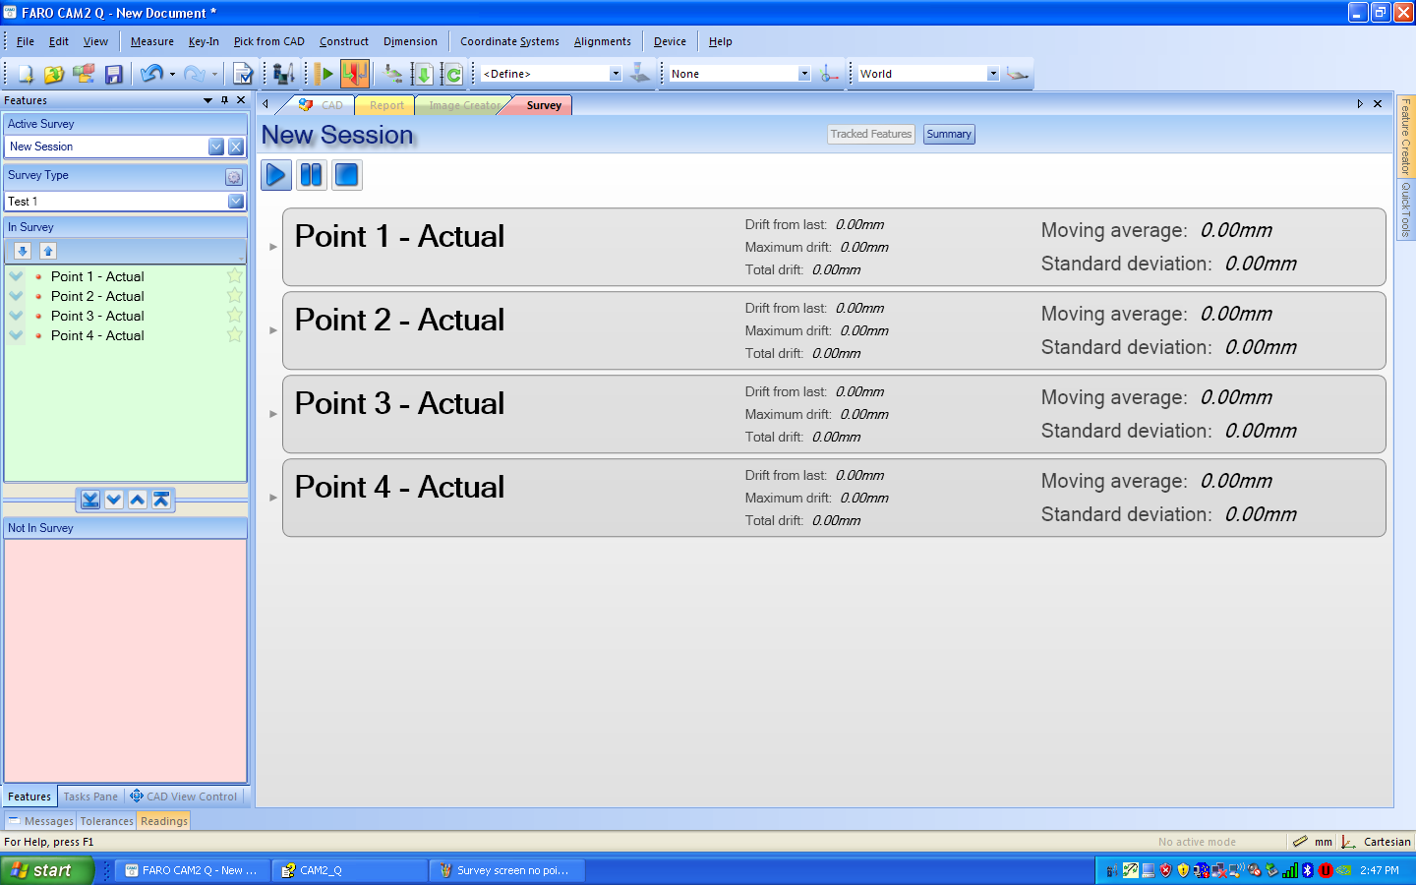

4. Click on the Survey Tab. Much like the report screen you will be able to select what to use on the left hand side. Either individually or as a group, move the desired points up to the “In Survey” section.

5. The points will be listed in the center of the screen with results for each. There is also a small arrow on the left hand side of the point data, this will expand the data to include X, Y, Z deviations.

6. Under “Active Survey” click in the text box and give the session a name.
7. Next to “Survey Type” click on the icon.

8. This will bring up the Survey Setup screen to configure the parameters of the survey.
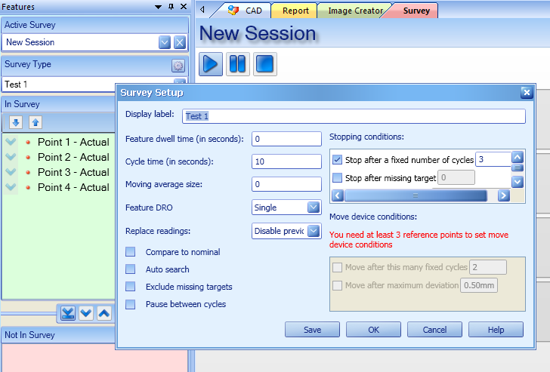

9. Give the configuration of this survey a name by typing in the Display Label area.

10. Click on the HELP button to see what each option means.

11. Feature Dwell Time can be set low (less than 10 sec); Cycle Time should allow for enough time to move the fixture or part; Moving Average Size allows you pic the number of cycles to refer back to for the average value; Feature DRO set to Single provides just one DRO window that changes as each point is measured; Replace Readings depends on the type of calculation you want done.

12. Compare to Nominal box should be checked if using nominal data. *You must have nominal data for all survey points to use this option.

13. Stopping Conditions: Check the “Stop after fixed number of cycles” and enter the # of cycles you would like to run.

14. When you have set up the survey, you can click OK to use the settings for the current survey, or click SAVE to save the settings to the survey template for future use.

15. Click the  icon to start the survey. There is also a 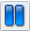 pausing and a 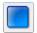 to stop the survey.
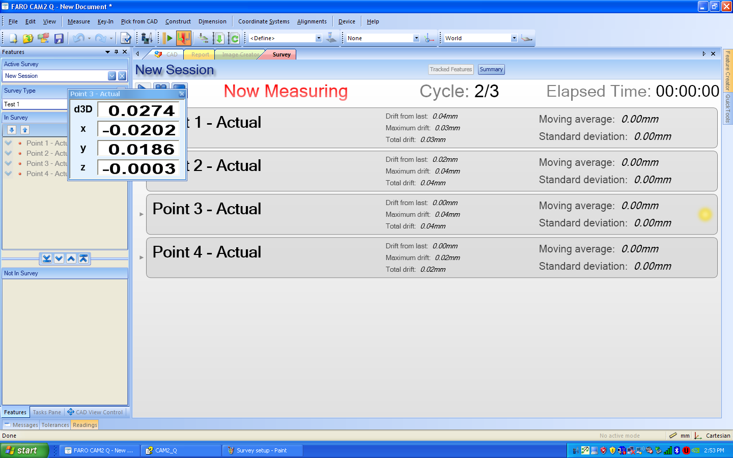

16. You will now see the DRO and the screen will say “Now Measuring”

17. At the end of the cycle the tracker and survey will be paused by the specified amount of time. If part of the check, this is when the movement should take place. (Ex: Opening and closing door)

18. Once the survey has completed you will see the “Elapsed Time” displayed and all cycles complete.

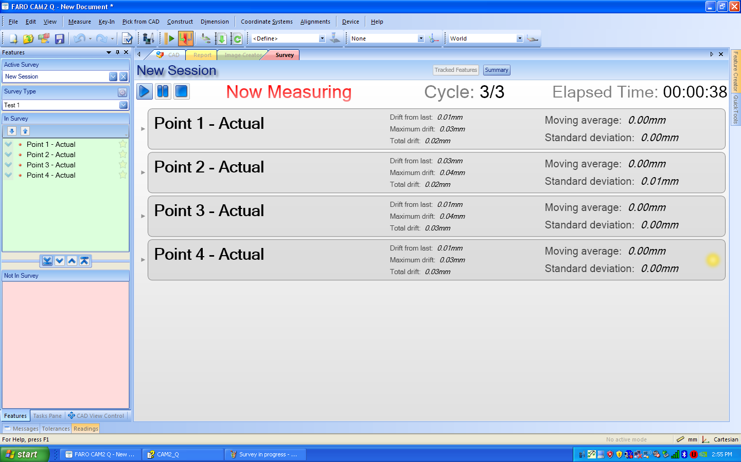

19. You will see a quick view of the data for each point. To get a print out of this data click the icon and then the 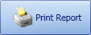 icon.

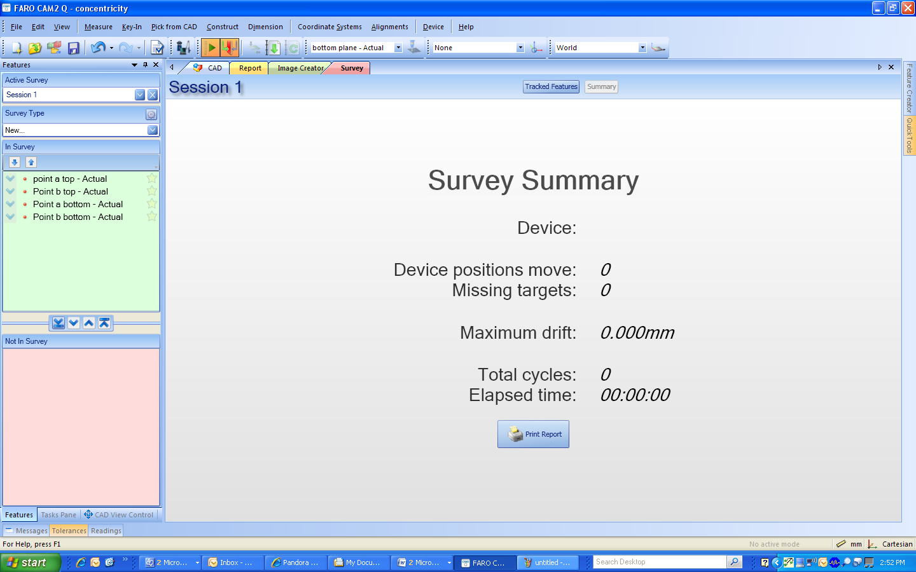
20. If you want more detailed info regarding each point you can click back into the CAD tab and look at the readings for each point. The data for each time the point was measured in the survey will be stored here.
This is a sample portion of what the report generated in the survey looks like so as you can see if you want individual point data you will need to run the report found in the Readings area.

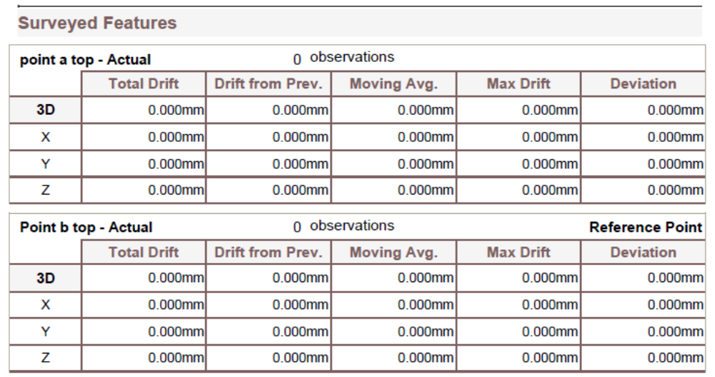

Implementing Move Device
You must make at least 3 of the points in the survey reference points. To do this click on the icon located to the right of the point. Reference points will now be denoted by this star icon.

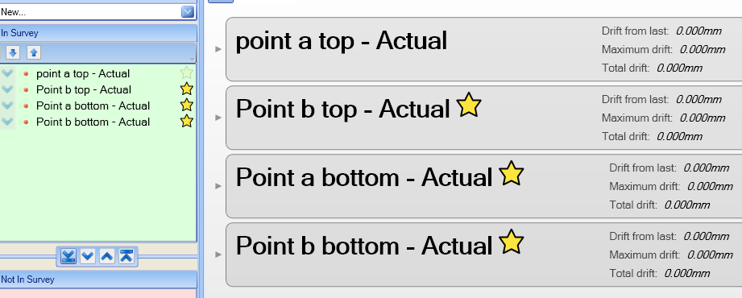

Once selected, the move device option in the survey setup will now be active. Pick the number of cycles you want completed before the move is done. The move device is automated in the survey. You can see the results for the new position in the Device Manager.

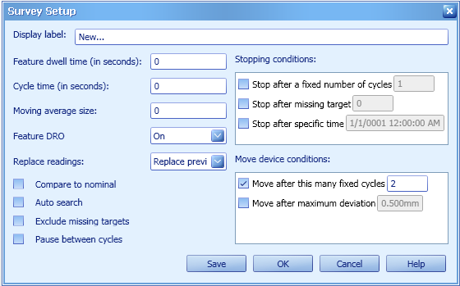

USA: Orlando, Detroit, Los Angeles, Chicago, Charlotte, Columbus, Seattle
Europe: Paris, France; Stuttgart, Gernany; Coventry, UK;Barcelona, Spain; Rivoli, Italy
Asia: Aichi, Japan
    - 407.324.7876 Fax: 407.333.4181

E-Mail: info@faro.com www.faro.com

