Application Method Sheet
Measuring a Round Tube in CAM2 Q v1.5 :
Round Tubes

Application Description
This method sheet will describe how to measure round tube sections in Cam2 Q v1.5. Several tube sections can be measured to construct a tube with multiple bends. It will also describe some of the settings and what they do.

Setup

- Software
  - Start a new measure Cam2 Q session.
  - Turn on template mode.
- Hardware
- Place the arm so that it can reach all the tube sections as well as the end planes. The end plane is where the tube intersects a wall or where it ends.

Part and Software Setup

- Step 1: Fixture the tube so that it doesn’t move relative to the arm. Place it in a way so that measurements can be taken around the tube section with the probe.
- Step 2: Click Measure>Tube.
  - A: Provide a custom name if desired.
  - B: Check “Override Diameter” and key in the nominal diameter of the tube. If left unchecked, Cam2 Q will average diameter of all the tube cylinders measured.
- C: Leave the start and end plane selections on “define”. The software will prompt for a start and beginning plane to be measured once the routine has begun. A previously measured plane can be selected instead of measuring a “define” plane.
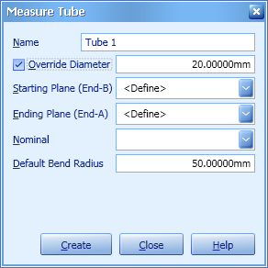

- D: Bend Radius - Key this in from the blueprint or CAD file. Note: Do not let Cam2 Q calculate this. This can be easily miscalculated depending on how close to the ends of the measured cylinders are to each other.
- E: To associate a nominal tube section while using an imported CAD model, go to Feature Creator>Pick from CAD>Tube. Click on the tube section on the model. Select all the desired tube sections. Without CAD go to Feature Creator>Key In>Tube. The tube nominal data can now be keyed is using Pull-Turn-Bend or the XYZ positions.

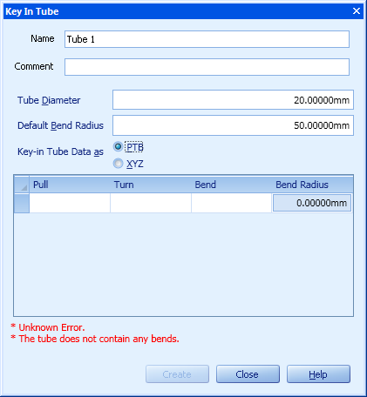
Measurement and Coordinate System

- Step 1: Select the tubes, right mouse click, and select add measurements. Measure the start plane for the first tube section. This plane does not have to be 90 degrees to the tube. The breakpoint will be calculated at the intersection of the cylinder and plane.
- Step 2: Measure the first tube section. It will be measured like a cylinder; take three points around the circumference at the first end, three points at the second end, and three points in the center of the tube. Add any additional points anywhere in between the tube section. Repeat until all tube sections are measured. Make sure they are measured in order. This is very important.
- Step 3: Once all tube sections have been hit the back button (red button on the arm) when the software asks for the next cylinder. Cam2 Q will automatically ask you to measure the end plane. Measure the end plane.
- Step 4: Setting up a Coordinate Systems (CS). There are several ways to measure a CS and set up an alignment. It is best to use the CS of the CAD part or where the most logical position on the part may be. To set up a CS just using the end planes and tube sections click on the Coordinate Systems drop down and select “Create Using the Wizard”. Click on the Advanced Tab. Use the breakpoints to create the CS. Highlight the plane icon and select the first three breakpoints to define a plane. In the secondary box, pick the first two breakpoints to define line for the line direction. For the origin box, pick the first breakpoint to define the origin. Click on Create at the bottom. This creates a simple origin to work with. Now all the tubes will be in reference to the created CS.

Review Data

Highlight any measured tube from the feature tree on the left side. Click on the feature information tab. The following information will be displayed for the tube:
- Flow length: The length of the tube along the center line.
- Diameter: The diameter of the tube.
- Start Breakpoint XYZ: The XYZ coordinates of the first breakpoint.
- A to B Length: The 3D length from the first breakpoint to the final breakpoint.

Reporting

Once in the report tab, the tube will now be an option to put on the report. In here the information about the tube will reside. Additionally, the Pull, Turn, and Bend information will be available. Pull is the tangent length of the cylinder, turn is the rotation of the tube, and bend is the bend angle of the cylinder. The XYZ breakpoints will also be displayed. The XYZ points are the intersections of the tube sections.

For questions and concerns please email FARO Customer Service:
Faro Technologies Inc. FARO EUROPE GmbH & Co. KG FARO Singapore Pte. Ltd
250 Technology Park Lingwiesenstr. 11/2 · 70825 3 Changi South Street 2,
Lake Mary, FL 32746 Korntal-Münchingen · Germany 486548 Singapore
1-800-736-2771 +49.7150.97.97-400 1800-511-1360
support@faro.com support@faroeurope.com supportAP@faro.com

Disclaimer: Faro Technologies, Inc. makes no warranty, express, implied or statutory, as to the material on this form, including any referenced third party. The material contained on this form is for informational purposes only; such material is provided “AS IS” and with all faults, and your use of the material is at your own risk.

