 | Application Method Sheet  Iterative Alignment in CAM2 Q v1.5 :  Best-fit (iterative) Alignment

Application Description
An iterative alignment is a best-fit alignment using point reducible features. It matches nominal points to measured points and can be incorporated with or without a CAD model. It must be created using 3 or more point reducible features that have been measured and have corresponding nominal values.

The following example uses a CAD file to establish a best-fit alignment between the actual part and measurement device. 4 nominal circles are selected on the CAD file and then measurements are added. The iterative alignment command is used to align the measured circles, in space, with the nominal circles position. This establishes a known relationship of the parts’ features instead of the original device position.

The iterative alignment is a useful tool when it’s not possible to create a coordinate system (CS) on the part due to inability to measure the features that make up the desired CS or the translation/rotation of the CS on the CAD is not known.

Setup
- Software
  - Translate and Import CAD file
  - Begin in Cam2 Q Template Mode
- Hardware
  - FAROArm or Tracker

Measurement
- Step 1: Pick From CAD>Circle – choose 4 circles on the CAD part

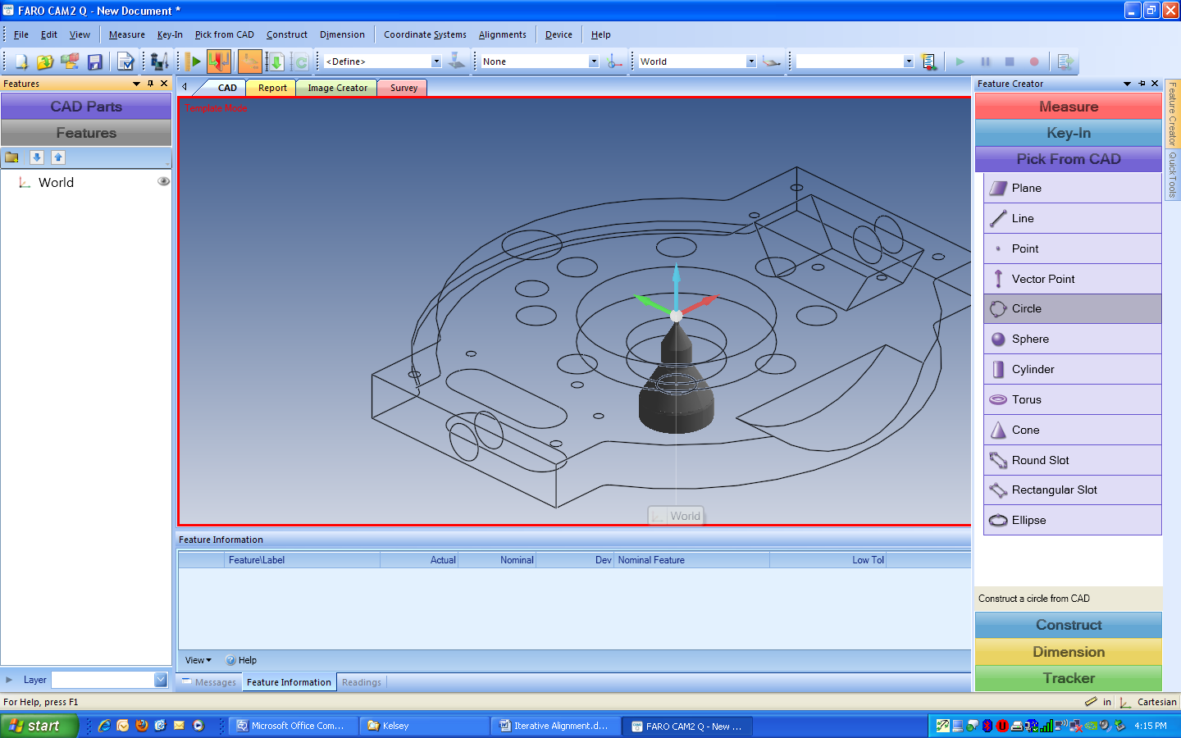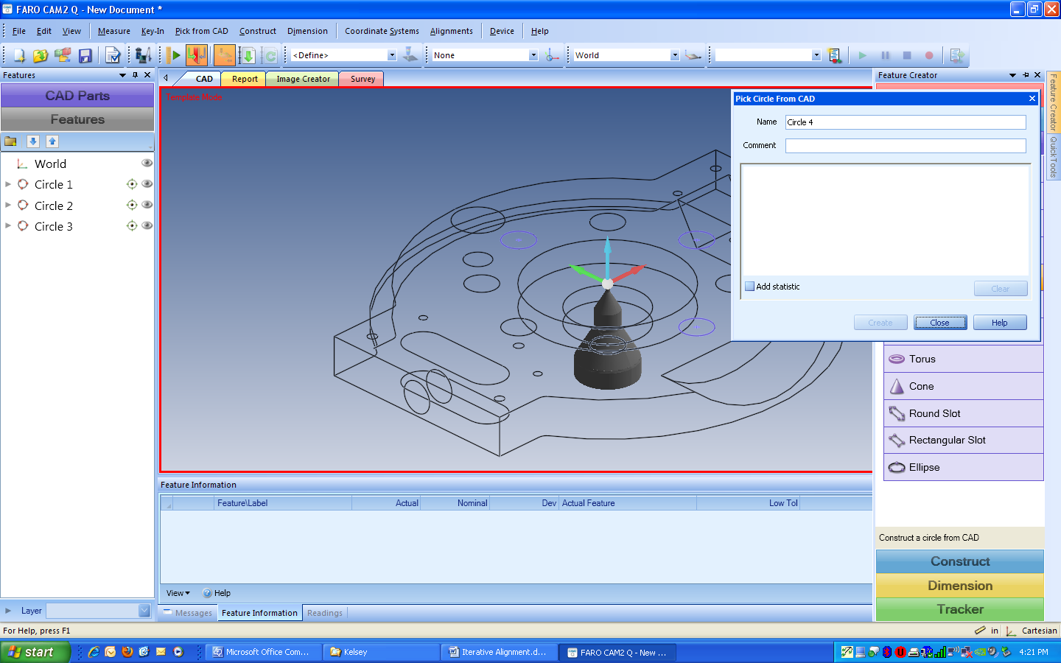

- Step 2: Add Measurements - Highlight all the circles on the left feature tree, right mouse click, and choose “Add Measurements”

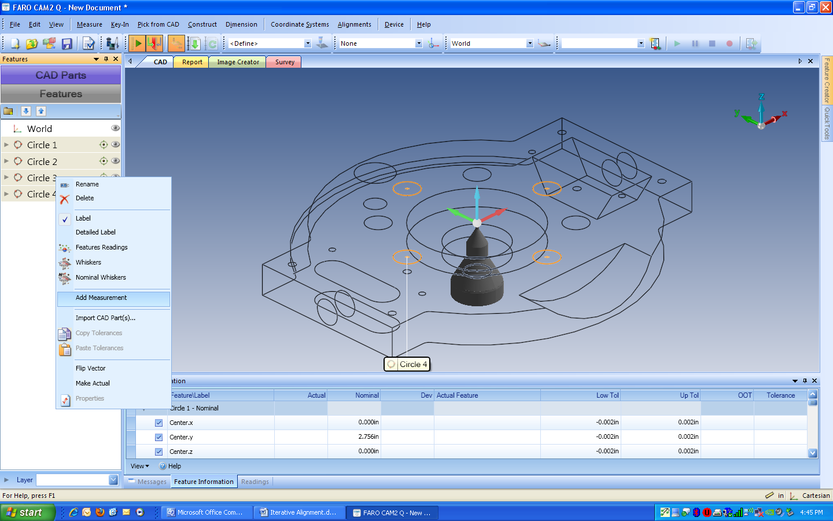

- Step 3: Measure all features – Once Add Measurements has been selected, a projection plane will be added since all 2D features require a projection plane. Measure the projection plane and the 4 circles

- Step 4: From the Alignment menu, choose Iterative Alignment

- Step 5: Highlight the 4 circles from the feature tree, the left panel, and press “Add Selection” in alignments window
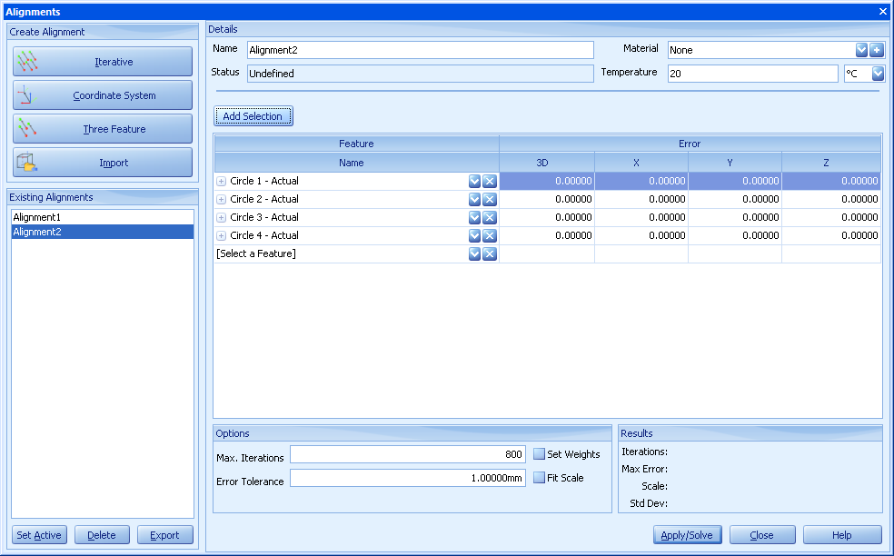

- Step 6: Press “Apply/Solve” button in alignments window. The max error is displayed in the results box. (Bottom right corner of alignment window)

- Step 7: After the features are remeasured and solved for the new device position, the Results portion of the Device Manager will display several important pieces of information. They are Iterations, Max Error, and Scale.
- Iterations – the number of times the software tried to best fit the previously measured features with the newly measured ones. The number of iterations is not an important factor in the calculation of the device move error or how effective the command preformed
- Max Error – the maximum error calculated by the software by best fitting the features together. If this number is extremely high, the most likely reason is the features were measured in the incorrect order.
- Scale – the temperature scaling factor
- Results Box without removing any features:
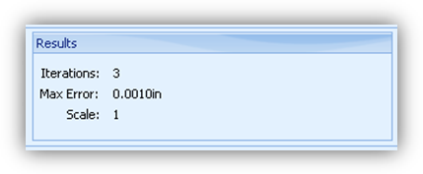

If the error is higher than desired or better results would like to be obtained, features can be removed from the calculation to improve the move device command.
- After the first move device is calculated, the error is now populated in the feature information. To improve overall error, sort the column by 3D error. The feature with the highest error can be removed by hitting the “X” next to the feature name.
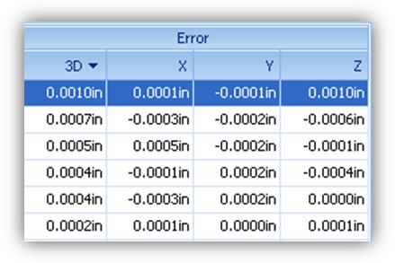
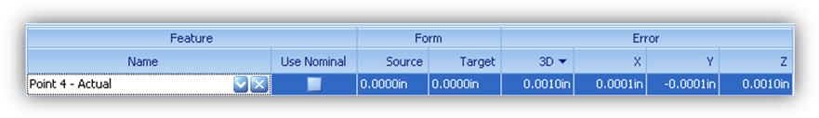
- Hit Solve again and then review the results and max error. This can be preformed until there are only three (3) features left. This is why Faro recommends using more than 3 features.

- Step 8: The part is now aligned to the CAD part using the CAD’s CS.

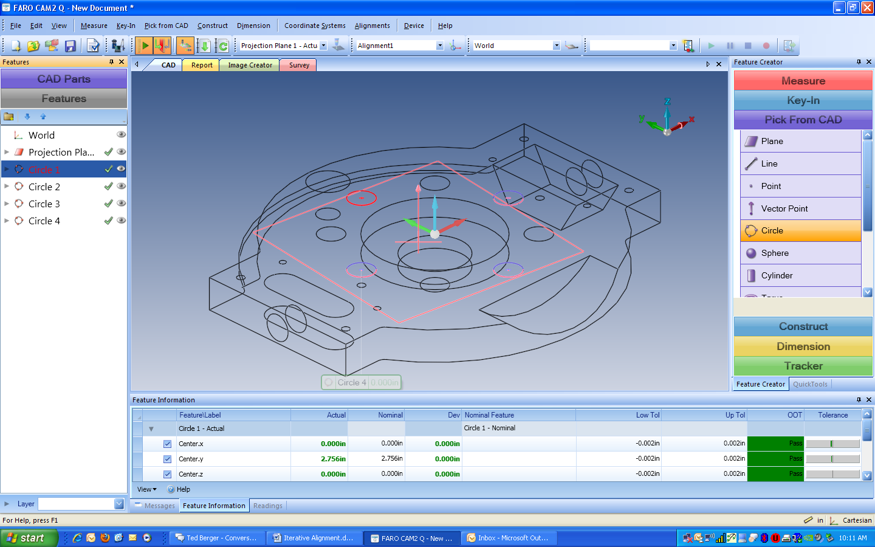

For questions and concerns please email FARO Customer Service:
Faro Technologies Inc. FARO EUROPE GmbH & Co. KG FARO Singapore Pte. Ltd
250 Technology Park Lingwiesenstr. 11/2 · 70825 3 Changi South Street 2,
Lake Mary, FL 32746 Korntal-Münchingen · Germany 486548 Singapore
1-800-736-2771 +49.7150.97.97-400 1800-511-1360
support@faro.com support@faroeurope.com supportAP@faro.com

Disclaimer: Faro Technologies, Inc. makes no warranty, express, implied or statutory, as to the material on this form, including any referenced third party. The material contained on this form is for informational purposes only; such material is provided “AS IS” and with all faults, and your use of the material is at your own risk.

