Application Method Sheet
Upgrading SCT Files from Cam2 4.0 to Cam2 X
SCT File Upgrade

Application Description
This method sheet will describe the process of upgrading or updating SoftCheck Tool (SCT) files from Cam2 4.0 to Cam2 X.

Setup
- Software
  - Just as a precaution, make sure all the Cam2 4.0 files are in a backup location, different from the default file location
  - Cam2 4.0 and Cam2 X installed on the same computer with a working port lock for each
  - Prewritten programs in Cam2 4.0 complete with pictures
  - Known location of the SCT files, preferably in the default FARO software file path
    - C:\Documents and Settings\All Users\Application Data\FARO
    - If a folder appears to be missing, turn the view on in the options. Go to Tools>Folder Options. Click on the View tab. Scroll down to “Show Hidden Files and Folders” and click on show.

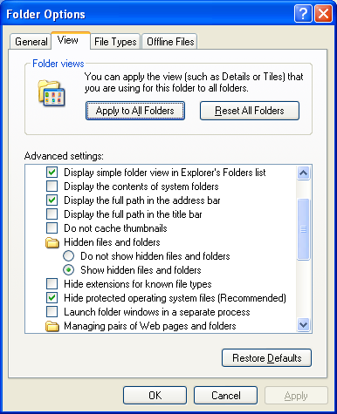

- Hardware
  - Computer with both software and working port lock(s) (dongle)

Upgrade Steps
- Make sure the Cam2 4.0 SCT program is performing precisely and that all the JPEG files were created correctly. If it’s not working in 4.0, it will not translate accurately.
- Open Cam2 X
- Go to File>Learn/Execute>Learn/Execute
- Do not save the file
- Select the radial button for SoftCheck Tools and click OK
  - Note: If a choice of SoftCheck Tools or Learn Files is provided, the port lock that is currently being used does not allow for SCT programming. Please try a different port lock with SCT enabled.

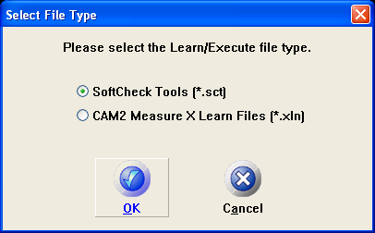

- Go to File>Upgrade 4.0
  - Note: The following error will show if the computer does not have 4.0 installed:

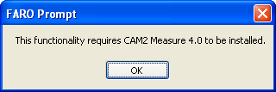

- The “Learn File Upgrade” will appear

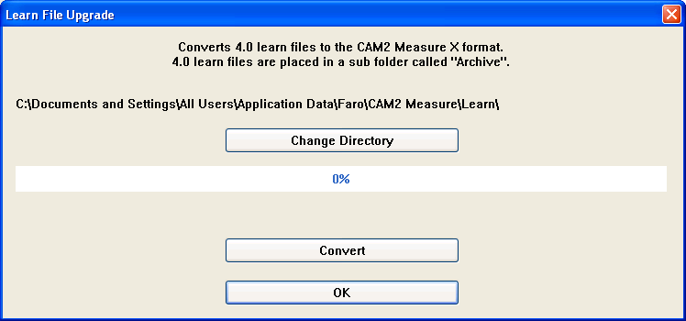
- Click “Change Directory” and navigate to the file folders where the Cam2 4.0 SCT files are located
  - The default FARO Cam2 4.0 directory is: C:\Documents and Settings\All Users\Application Data\Faro\CAM2 Measure\Learn\
- Click “Convert”
  - Note: A possible translation error may occur; see “Possible Errors” section
- Once complete, select OK to close the “Learn File Upgrade” box
- The SCT files are now ready to be used normally
  - Be aware that the upgraded Cam2 X SCT files may be stored back in the Cam2 4.0 directory. See below if this occurs.

Possible Errors and Issues
- If the JPEG files are not correct in 4.0, then when it is translated to X perfectly. Using the X SCT, the pictures will all have the same base image for all features with no green or red balls.
- After the Convert operation is completed, an error may appear indicating a specific number of files failed to upgrade and the location to view the upgrade log. Select OK to close the prompt. Note: There are no known issues with this and is likely associated with the .sat file not translating into an .fce file.

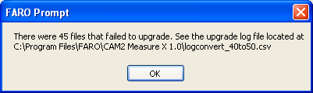

- When Cam2 X is opened, the Program may need to be directed to the Cam2 4.0 directory in order to open converted SCT files. The default location for SCT files in X differs from the default location for 4.0 SCT files. If the converted files do not appear in the “Learn Files” dialogue box, click Directory and navigate to Cam2 4.0’s default location for SCT files.

  - Default X: C:\Documents and Settings\All Users\Application Data\Faro\CAM2 Measure X 1.0\Learn\
  - Default 4.0: C:\Documents and Settings\All Users\Application Data\Faro\CAM2 Measure\Learn\
- During the file conversion operation, select NO to save files
- When opening the newly upgraded files, the software ask for a new drawing file. This means the .sat file did not convert and/or there is no .fce file associated with the new X SCT. There are no known issues associated with this. Click OK to create a new .fce file. Ensure that the SCT file is saved and the new .fce file is saved as well.
- Occasionally items such as the Device position, nominals, and some features may provide an error when opening the new X file. The software will indicate an item appears to be missing. There are no known issues associated with this and the items are still located in the command line. Click OK to continue.

For questions and concerns please email FARO Customer Service:
Faro Technologies Inc. FARO EUROPE GmbH & Co. KG FARO Singapore Pte. Ltd
250 Technology Park Lingwiesenstr. 11/2 · 70825 3 Changi South Street 2,
Lake Mary, FL 32746 Korntal-Münchingen · Germany 486548 Singapore
1-800-736-2771 +49.7150.97.97-400 1800-511-1360
support@faro.com support@faroeurope.com supportAP@faro.com

Disclaimer: Faro Technologies, Inc. makes no warranty, express, implied or statutory, as to the material on this form, including any referenced third party. The material contained on this form is for informational purposes only; such material is provided “AS IS” and with all faults, and your use of the material is at your own risk.

