Application Method Sheet
Surface Point Alignment (Iterative) in CAM2 Q v1.5 :
Best-Fit Alignment Using Points

Application Description
When inspecting a part that does not contain geometry easily measured as basic CAD features for a Coordinate System Alignment, an Iterative Surface Point Alignment can be used to achieve the needed association of measurements with the CAD file. This method sheet will illustrate the necessary steps to complete this type of alignment and will also enable the CAD to part nominal association for future measurements.

Setup
• Normal setup and probe calibration considerations need to be made for the part and the arm
• Verify the CAM2Q settings for Auto/Nominal Association in Edit>Preferences; see the “Measurement” and the “Auto Nominal” Tab
o Check box needs to be checked on
o settings need to be appropriate
(Defaults are 5.0 degrees/.1 position/.1 size)

Measurement
• Step 1: Open a new .FCD file (Cam2 Q measurement file) and import the CAD file for the part of consideration in to the display
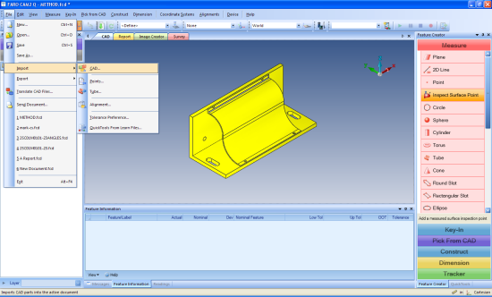

• Step 2: Select the surface to have a point measured on in the display so that it highlights red

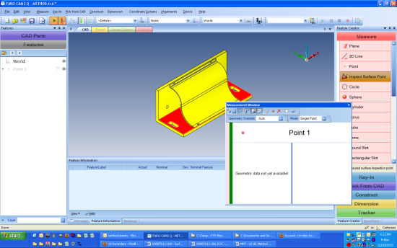

• Step 3: In the Feature Creator Panel, under Measure, select Inspect Surface Point; the Measurement Window will appear
• Step 4: Select three points on the first surface; it should be the largest surface
• Step 5: Change the highlighted surface in the display window to the second surface, and select two points on it; it should be oriented near orthogonal (at 90 degrees) to the first surface
• Step 6: Change the highlighted surface in the display window to the third surface, and select one point on it; it should be oriented near orthogonal to both the first surface and the second
• Step 7: select Alignments>Iterative Alignments and the Alignment wizard will appear; highlight the six points created thus far for the alignment in the Features Panel and then click add selection button
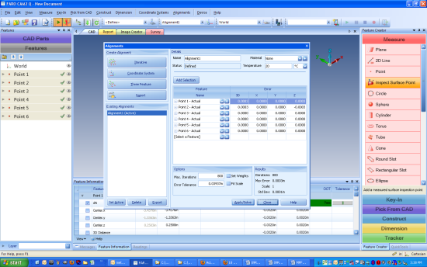

• Step 8: In the lower right-hand corner of the Alignment window, click Solve

Review Data
Analyze the error associated with the solution generated; this error should be lower than the lowest tolerance value for the part

Closing the Alignment window will return the screen to the Display window. Note: that the points measured and utilized in the alignment are displayed as simple discs, and now hold a color indicating their fit with the alignment.

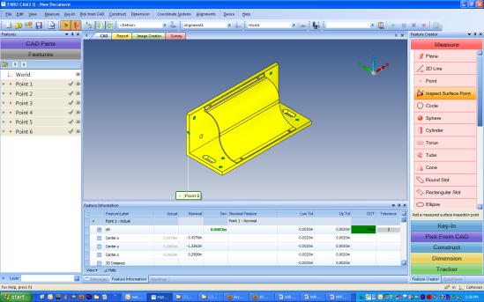

For questions and concerns please email FARO Customer Service:
Faro Technologies Inc. FARO EUROPE GmbH & Co. KG FARO Singapore Pte. Ltd
250 Technology Park Lingwiesenstr. 11/2 · 70825 3 Changi South Street 2,
Lake Mary, FL 32746 Korntal-Münchingen · Germany 486548 Singapore
1-800-736-2771 +49.7150.97.97-400 1800-511-1360
support@faro.com support@faroeurope.com supportAP@faro.com

Disclaimer: Faro Technologies, Inc. makes no warranty, express, implied or statutory, as to the material on this form, including any referenced third party. The material contained on this form is for informational purposes only; such material is provided “AS IS” and with all faults, and your use of the material is at your own risk.

