|  |
| --- |
| **Customer Service Department *Technical Guides*** |
| **Topic: Tomography 101. Procedure for creating a Floor Plan.** |
| 3 Pages total including this page. Contact FARO’s CSD Department immediately if pages are missing or not legible. |

|  |  |
| --- | --- |
| **Table of Contents** |  |
| Contents  **Purpose** 1  **Instructions** 1  **Reviewing Results in 3rd Party Software** 2  **Revision History** 3 | |

**Purpose**

This document explains how to create a flat, simple outline of scans for use in making floor plans using a tomograph in FARO Scene.

**Instructions**

First you will need to set you Tomography settings in Tools > Options

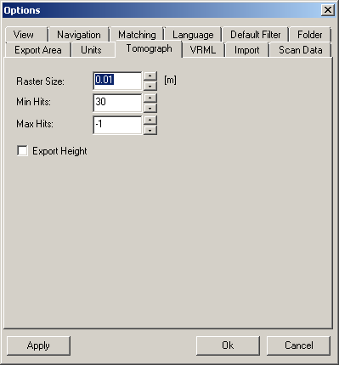

* The Raster size determines point density along the scan points selected. The lower the number, the more dense the points. The default number provided is very high and the points extracted are correspondingly sparse. However, if you drive the number too low you can blow up your file size with little return on improved data.
* Min Hits defines the minimum number of scan points with which a raster field turns black. It determines how many points are required to decide if it is a part of a vertical surface (ie wall). The higher the number the more things like tables, filing cabinets, etc will be excluded from the data set.
* Max Hits defines the maximum number of scan points with which a raster field still turns black. If the number is exceeded, the raster field is rated as blank. The specification of –1 means an infinite number.

Once these settings are set, you are ready to export.

Right click over the scan or over the scans folder and select Import/Export > Scan Points

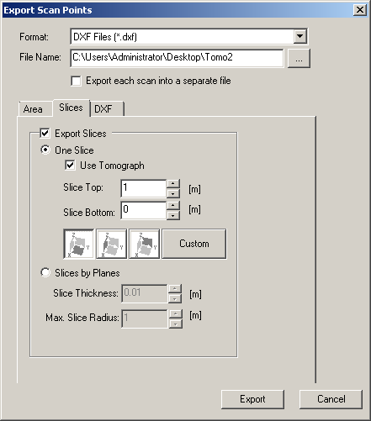

* Select your export format and file name.
* Select the Export Slice tab. Check the Export Slices check box.
* Select the Use Tomograph check box.
* Select the slice top and bottom by entering a value.
  + Keep in mind that 0,0,0 is at the height of you reference scan and thus is already 1-2 meters off the floor.  This will determine what points will be used to calculate the slice. If the slice is larger you can bump up your Min Hits in your options settings, if smaller you may need to dial down the min hits. The idea is to get enough vertical surfaces (walls) to create a good outline.

**Reviewing Results in 3rd Party Software**

Below is an example after importing the file created into AutoCAD. It displays a clean set of points that define the vertical surfaces of the room. All the points have been projected to a single plane so there is no Z component to the data. From hear the user can begin to “trace” the room layout by snapping to the points and creating a floor plan.

The best results can be obtained by modifying the options settings and the slice location/thickness to see what values work best.

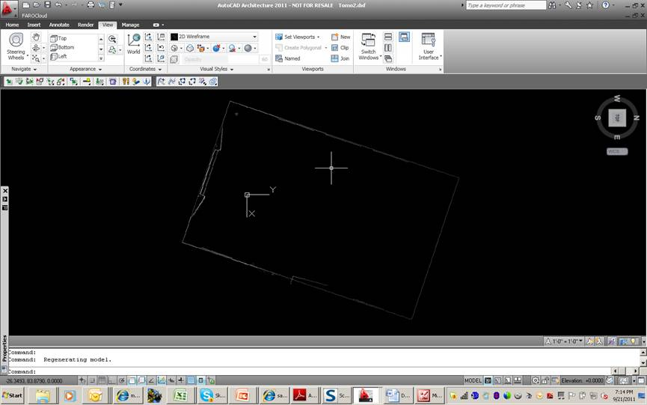

|  |  |  |
| --- | --- | --- |
| **For questions and concerns please email FARO Customer Service:** | | |
|  |  |  |
| FARO Technologies Inc.  250 Technology Park  Lake Mary, FL 32746  (Phone number here)  [**support@FARO.com**](mailto:support@faroeurope.com) | FARO Europe  (Address here)  (Phone number here)  [**support@FAROeurope.com**](mailto:support@faroeurope.com) | FARO Singapore  (Address here)  (Phone number here)  [**supportAP@FARO.com**](mailto:supportAP@faro.com) |
|  |  |  |
| **Disclaimer:** FARO Technologies, Inc. makes no warranty, express, implied or statutory, as to the material on this form, including any referenced third party. The material contained on this form is for informational purposes only; such material is provided “AS IS” and with all faults, and your use of the material is at your own risk. | | |

**Revision History**

* <http://connect.faro.com/sites/intranet/Quality/Lists/Document%20Control%20Log%20%20HQ/DispForm.aspx?ID=15401&Source=http%3A%2F%2Fconnect%2Efaro%2Ecom%2Fsites%2Fintranet%2FQuality%2FLists%2FDocument%2520Control%2520Log%2520%2520HQ%2FOpen%2520Items%2Easpx>. Date revised: 3/29/2012