Application Method Sheet
Three Feature Alignment :
Aligns to Primary, Secondary and Tertiary Features
Application Description
The three feature alignment uses three features to give a more exact alignment without a best-fit or iterative alignment. Best-fitting attempts to evenly distribute the error across the features selected whereas feature alignment allows the operator more control to where the error will be distributed.

The feature alignment solves as such:
- The primary part feature moves exactly to its nominal. There will be no alignment error between the actual and nominal feature.
- The secondary feature moves as close to it’s nominal without moving the primary feature. There will be some error between the actual and the nominal feature.
- The tertiary feature moves to its nominal without moving the primary and secondary features. The greatest alignment error will be between the actual tertiary feature and the nominal.

Setup – Using CAD
- Translate CAD file, File>Translate CAD Files.
  - From the FARO CAD Translator, select “Add files”.
  - From Add CAD Files for Translation, select FARO_Demo_Part1.igs.
  - From the FARO CAD Translator, select “Start translation”.
  - Close the FARO CAD Translator.
- Import CAD file, File>Import>CAD.
- Select nominal features from the imported CAD model,
  - A multitude of features can be selected as nominals from the Pick from CAD>Feature Type command
  - Ex: Circles: Pick from CAD>Circle and select 3 circles. Rename the features as necessary. In this example the circles are renamed to “Point #”.
  - See Figure 1.
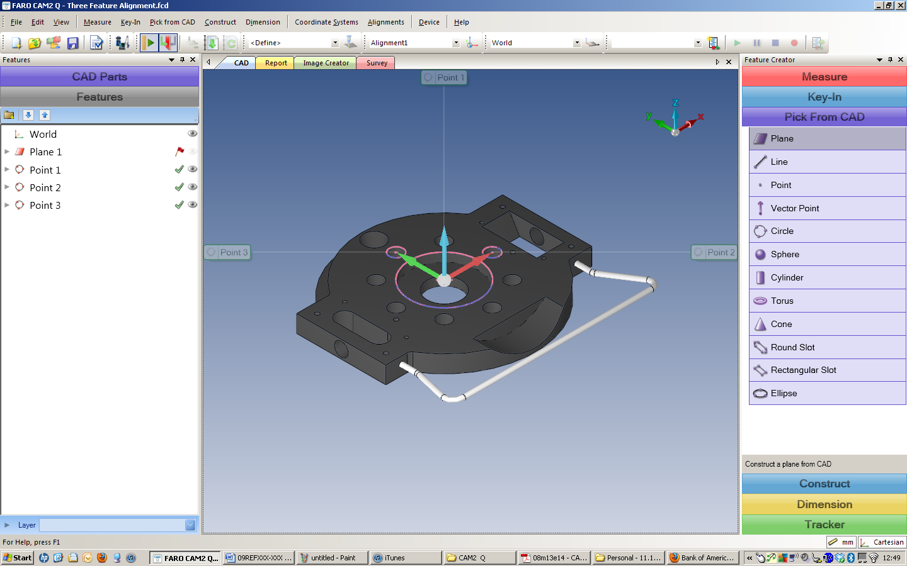
Figure 1. Pick from CAD.

Three Feature Alignment
- Measure the selected features.
  - Highlight the features from the Feature Panel. This includes Plane 1 (used to project the 2D circle features), Circle 1, Circle 2 and Circle 3.
  - Right click and select “Add Measurement”.
    - See Figure 2.
  - Measure the features using the device.

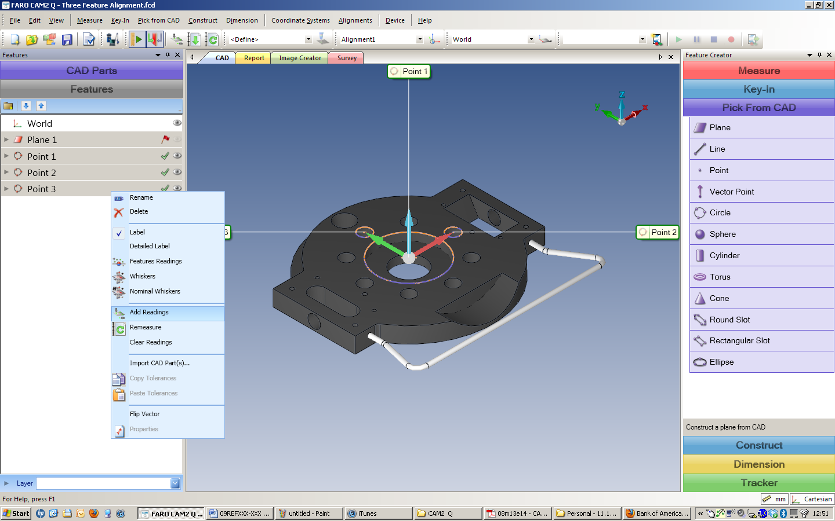
Figure 2. Add Readings.

- Align the CAD to the measured data using the Three Feature Alignment: Alignments>Three Features.
  - Alignment Method = Point, point, point (since the 3 circles are point reducible)
    - Primary Point = Point 1
    - Secondary Point = Point 2
    - Tertiary Point = Point 3
      - See figure 3.
  - Select the Apply / Solve button.

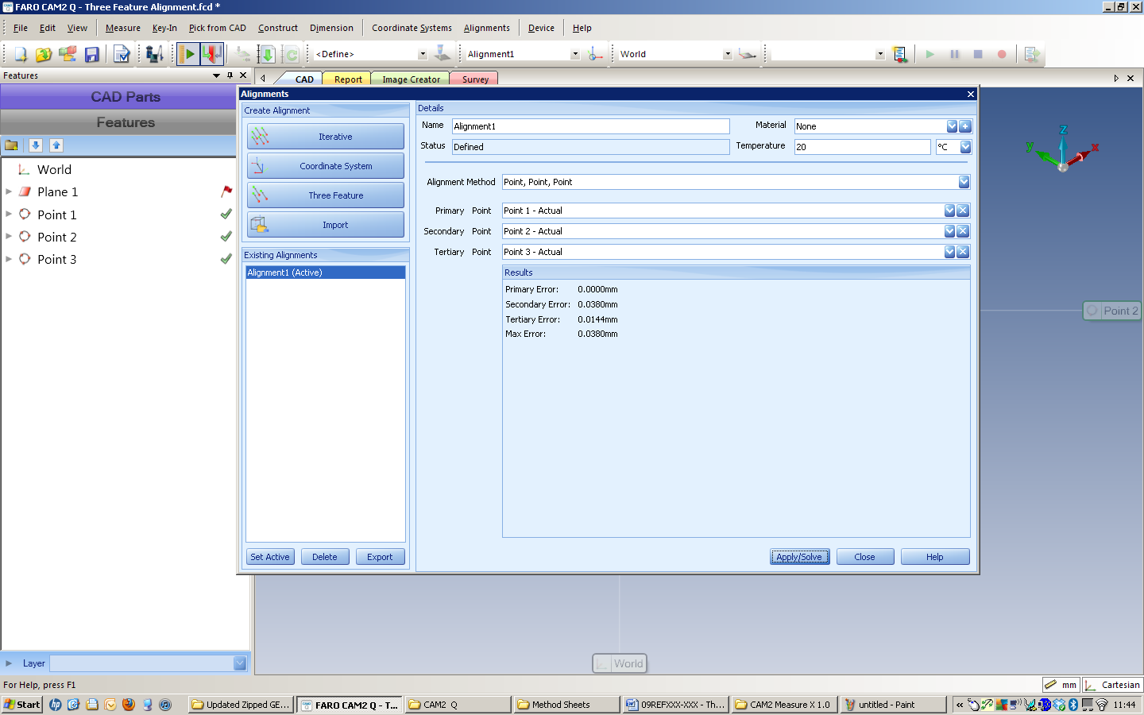
Figure 3. Three Feature Alignments.

Review Data
- From the features panel, highlight the features that need to be reviewed.
  - Review the results of the alignment. Referencing the arrows below, note that the primary feature has an error of zero in all three directions.
    - See figure 4.
  - The secondary has a minimal error that is distributed along the x axis.
  - The tertiary has the greatest error that is distributed along the x and y axis.
  - Interpreting the data – based upon the explanation of the three feature alignment, the error is consistent to what one would expect.

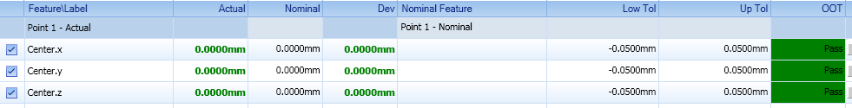
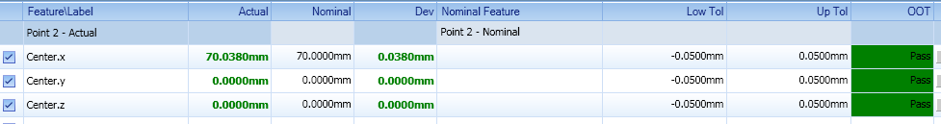
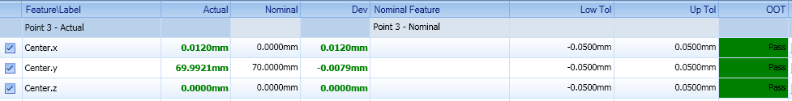
Figure 4. Error Distribution.

Reporting
- From the features panel, highlight the features that need to be reported.
  - See figure 5
- Select the Report tab from the main window.
  - See figure 6.

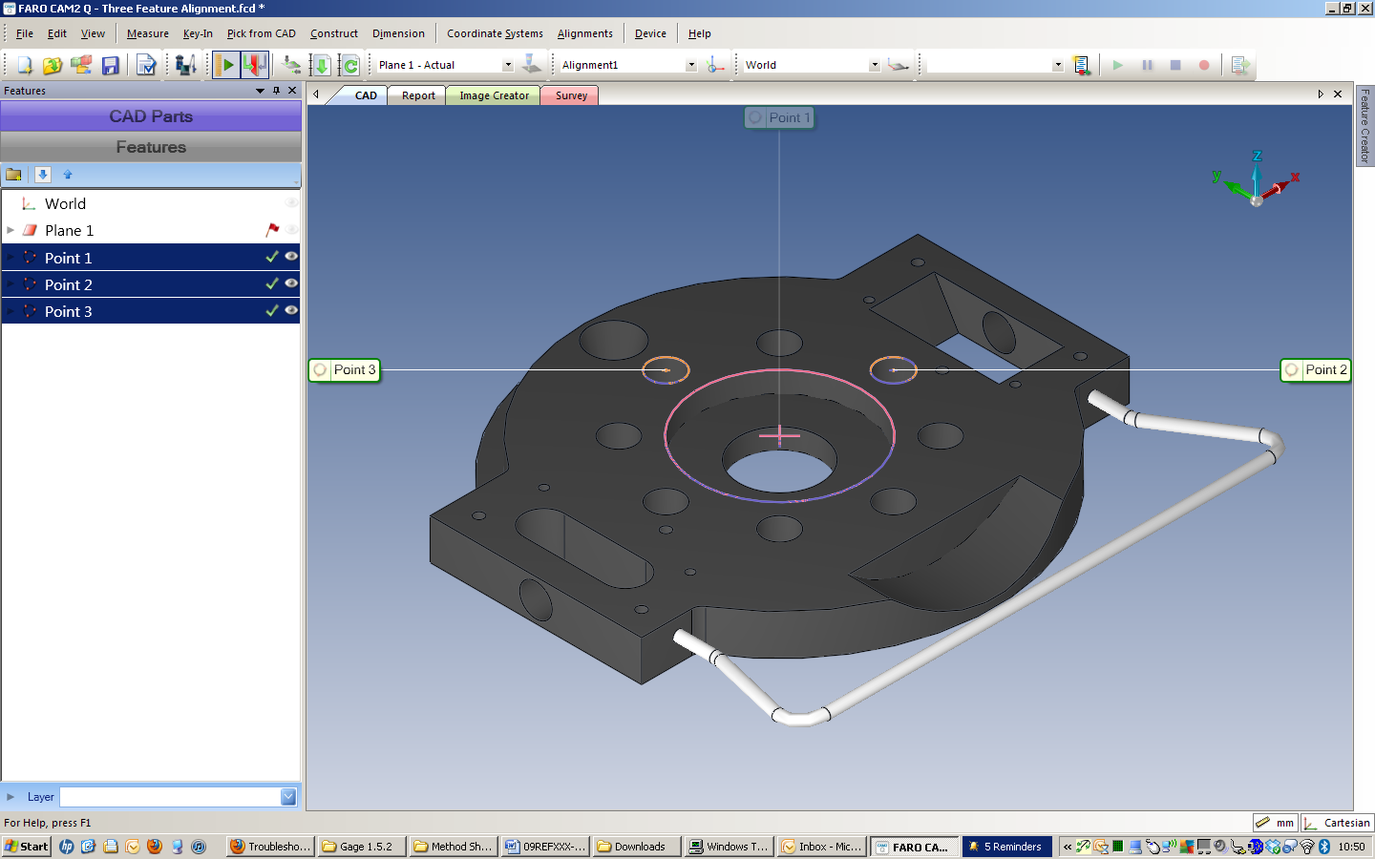
Figure 5. Select Features.

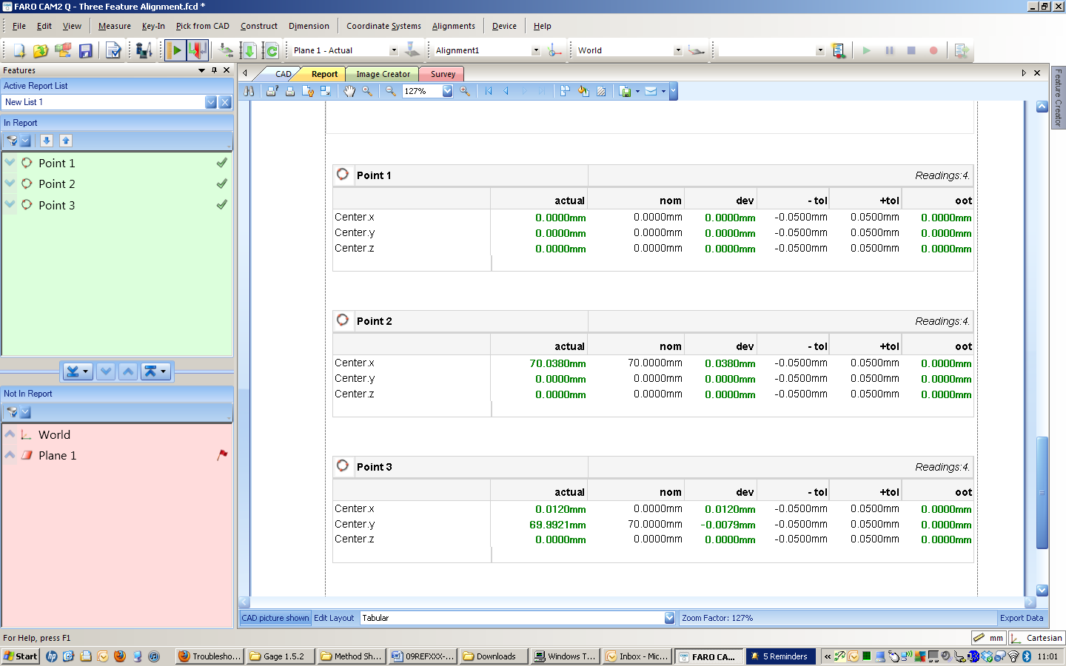
Figure 6. Report.

For questions and concerns please email FARO Customer Service:
Faro Technologies Inc. FARO EUROPE GmbH & Co. KG FARO Singapore Pte. Ltd
250 Technology Park Lingwiesenstr. 11/2 · 70825 3 Changi South Street 2,
Lake Mary, FL 32746 Korntal-Münchingen · Germany 486548 Singapore
1-800-736-2771 +49.7150.97.97-400 1800-511-1360
support@faro.com support@faroeurope.com supportAP@faro.com

Disclaimer: Faro Technologies, Inc. makes no warranty, express, implied or statutory, as to the material on this form, including any referenced third party. The material contained on this form is for informational purposes only; such material is provided “AS IS” and with all faults, and your use of the material is at your own risk.

