Application Method Sheet
Vector Point Iterative Alignment in CAM2 Q v1.5 :
Best-Fit Alignment Using Vector Points

Application Description
Vector point alignment is a form of aligning a part to a CAD model. The measured data must have nominal data to compare to in order to correctly align. The alignment takes the measured points and best-fits them onto the nominal points in order to align the system together. There must be enough points to fully constrain all degrees of freedom in order to complete the alignment.

You will be able to:
- Create specific nominal vector points on a CAD surface for use in an alignment.
- Measure and align the points to the nominal data. Finally, re-measure the vector points on the part to improve the alignment error and edit the results of the alignment.

Setup
- Software
- Open a new Cam2 Q file
- File>Import CAD to bring in the CAD part file
- On the Pick from CAD menu, click Vector Point.
- Click 3 points on the top of the CAD model Surface.
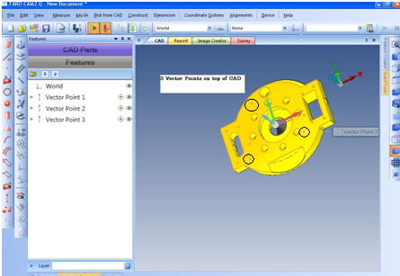

- Rotate the CAD model and Click 2 points on the left side of the CAD model surface.

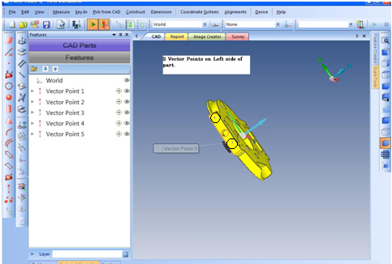

- Rotate the CAD model again and Click 1 point on the front of the CAD model surface.
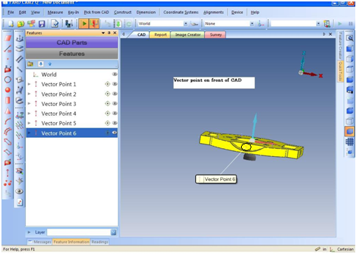

Note: The minimum requirement is only 4 vector points. It helps to thinks in terms of locking down each of the 3 coordinate directions when picking your points. If more point then the minimum are used, the points with the highest error can be eliminate in the final steps.
- In the Features panel, select All Vector Points.
- Right mouse click on the features and select Add Readings.
- Measure the surface with a single reading for each vector point as prompted. Place the probe on the corresponding surface and take a point. The probe only needs to be in the general area of the nominal point at this time.
- In the Features panel, again highlight All Vector Points.
- On the Alignments menu, click Iterative Alignment. Click the Add Selection button to quickly add the vector.
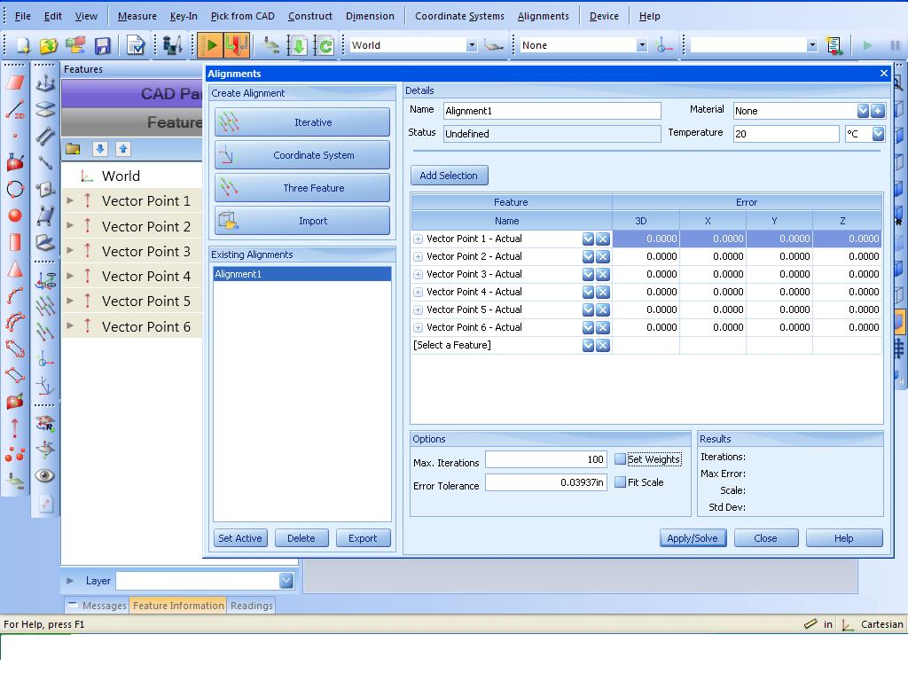
- Select the Set Weights check box to set the weight (or importance) vector direction for each point. The values are from 0 to 1 with 1 being the most important. This features allows a particular point to only be solved in a particular direction or a combination.
- Click the Apply/Solve button. Notice the max error and standard deviation. Do not worry about it being high. The next section will show how to remeasure the points and reduce this error.

Measurement
- In the Features panel, select All Vector Points.
- Right-click and select Re-measure.
- The model will rotate and zoom into the point that is currently being measured. Touch the surface and move the probe, or SMR, while watching the screen. Notice the circular zone around the vector point. When the probe, or SMR, is within the zone, you can record a single reading. Repeat the above for the rest of the vector points.
Note: In the preference menu, the software can be configured to automatically take a point when it’s in the “Home In” zone (the white area on the screen or when the sound is made when the probe is near the area). This zone can also be reduced in size to hone in tighter on the area.
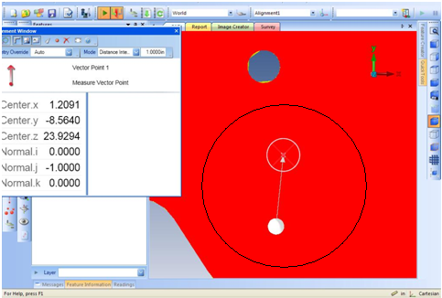

- Select Each Vector Point and look at the results in the Tolerances panel to view the results of how well the points are aligned. Also, by selecting Alignment>Create/Edit.
The error is now be seen in the feature information.
- To improve overall error, sort the column by 3D error. The feature with the highest error can be removed by hitting the “X” next to the feature name.
- Hit Solve again and then review the results and max error. This can be preformed until there is not enough features to fully constrain the part to the CAD model.

For questions and concerns please email FARO Customer Service:
Faro Technologies Inc. FARO EUROPE GmbH & Co. KG FARO Singapore Pte. Ltd
250 Technology Park Lingwiesenstr. 11/2 · 70825 3 Changi South Street 2,
Lake Mary, FL 32746 Korntal-Münchingen · Germany 486548 Singapore
1-800-736-2771 +49.7150.97.97-400 1800-511-1360
support@faro.com support@faroeurope.com supportAP@faro.com

Disclaimer: Faro Technologies, Inc. makes no warranty, express, implied or statutory, as to the material on this form, including any referenced third party. The material contained on this form is for informational purposes only; such material is provided “AS IS” and with all faults, and your use of the material is at your own risk.

