Customer Service Department Method Guide

Topic: Importing registered scans into a third party software.

SETUP

Make sure your project/workspace is properly registered in SCENE prior to importing and ensure the following:
- Preview the scans in 3D to review the registration
- Verify that the Scan Managers’ values are within acceptable results

METHOD

Some software will import fls (FARO laser scan) files only and others will import both fls and fws (FARO Workspace) files. Determine which import option is available for use one of the methods below for importing the data:

FWS IMPORT

- If working on the project level (.lsproj), create a fws file for the import by clicking the “Create Local Workspace” button
  - If working on a local workspace (.fws), it is recommended to save to the project using the “Share Changes” button so the project will reflect the final changes. When working on the project level, this button will not be available for use (refer to step #1).
- After creating the fws, use the import/index options in your third party software to bring in the fws file. All scans linked to the fws file will be imported. Note: The import process may take a while.

FLS FILE IMPORT

Warning: DO NOT import fls files from the RawScans folder as they do not hold translation and transformation information created during registration. Only fls files in the “Revisions” folder should be imported.
- In order to easily locate all of the fls files needed for import, perform a general filter on the project by right-clicking on the upper level Scans folder and selecting Operations > Preprocessing > Preprocess Scans…
- Check the “Filter Dark Scan Points” checkbox. The reflectance threshold can be left at 200 (default), however, if a more aggressive dark filter is desired it can be performed at this time.
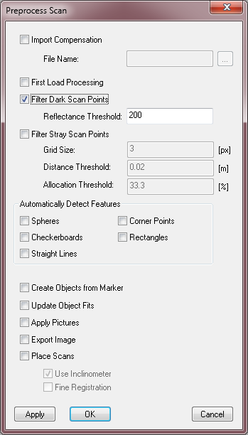
- Click “Apply”
- Save the changes
- If working on a local workspace (.fws), “Share Changes” to the project then “Open Project” .
  - When working on the project level, the “Share Changes” button is not available for use and a revision level was created during step #4
- “Clean up and compact” the project. Make note of the number associated with the “new base revision” prompt.
- Using a file explorer, navigate to the project’s location
- Navigate into the “Revisions” folder and then into the revision number noted from step #5
- Navigate into the folder’s “Scans” folder to locate the fls files needed for import into the third party software.

For questions and concerns please email FARO Customer Service:
Faro Technologies Inc. FARO EUROPE GmbH & Co. KG FARO Singapore Pte. Ltd
125 Technology Park Lingwiesenstr. 11/2 · 70825 3 Changi South Street 2,
Lake Mary, FL 32746 Korntal-Münchingen · Germany 486548 Singapore
1-800-736-2771 +49.7150.97.97-400 1800-511-1360
support@faro.com support@faroeurope.com supportAP@faro.com

Disclaimer: Faro Technologies, Inc. makes no warranty, express, implied or statutory, as to the material on this form, including any referenced third party. The material contained on this form is for informational purposes only; such material is provided “AS IS” and with all faults, and your use of the material is at your own risk.

