Technology Park, Lake Mary, FL 32746
Customer Service Department Fast Fax

To: FARO Arm User From: Customer Service Department
5 Pages total including this page. Contact us immediately if pages are missing or not legible.

TOPIC: Acceptance / Accuracy Verification for FARO Gage Arms.

Results of Accuracy Tests
Please initial each test to make sure they have all been performed. All the data must be recorded and the print outs attached to the e-mail at (support@faro.com) or fax (407-333-8056) to prevent delays or additional requests.
It is important the all information below is sent to FARO Customer Support to properly diagnose the equipment. Any questions please contact us at 1-800-736-2771.

INSTRUCTIONS ARE TO FOLLOW ON PAGE 2.

Preliminary Arm Evaluation Initials
1. Training:
a. Have you been trained by FARO? (Yes or No) ________
2. Mounting:
a. Have you checked your mounting? (Yes or No) ________
b. Attach pictures of the FARO Arm setup. ________
c. Attach pictures of the artifact mounting. ________
3. Environmental Conditions / Setup:
a. Provide details on your environment. ________
4. Diagnostic Test:
a. Was the temperature stable? (Yes or No) ________
b. Attach printout of temperature. ________
5. Probe Condition:
a. Is your probe tight / secure? (Yes or No) ________
b. Has your probe been dropped before? (Yes or No) ________
c. Do you see any signs of damage on the probe? (Yes or No) ________
6. Probe Calibration:
 | Probe Calibration #1 | Probe Calibration #2

X
Y
Z
Tip Error

a. Attach printout of probe calibration #1. ________
b. Attach printout of probe calibration #2. ________
7. Length Accuracy Certification Test
a. Attach length accuracy certification test. ________

---------------------------------------------------------------------------------------------------------------------------------------------------------------------
** Once all the tests have been performed and pictures are taken, please fax or e-mail these pages and all of your test results/pictures to the Customer Service Department at (407) 333-8056 or support@faro.com. **
---------------------------------------------------------------------------------------------------------------------------------------------------------------

Preliminary Arm Evaluation Test Instructions

- Training:
  - When you are trained by FARO Technologies you will receive a certification number. List you certification on this document. If not trained by FARO Technologies, Inc. Select the answer - “No”.

- Mounting Technique:
- Proper mounting is very important when using the FARO Arm. Listed in the “FAROARM USB USERS GUIDE” manual supplied with the FARO Arm on pages 5 & 6 it show you the proper mounting techniques.
- Before sending in your results make sure you include the pictures of the mounting / setup of your FARO Arm.
- Include pictures of the artifact you are measuring and how it is mounted.
- Approved Methods of mounting the Gage - Gage Vacuum Mount (Item #:1001-1015), Surface Mount Plate (Item #:1001-1023), Magnetic Mount (Item #:ACCS0046) & Granite Rolling Cart (Item #:ACCS0164).

NOTES:
Plates must be mounted to a secured Surface, Fixing the Gage to a metallic material may make it prone to vibration affects. Also, ferrous materials are prone to expansion and contraction making then not as thermally stable as ceramic materials such as granite or marble.

- Environmental Conditions / Setup:
- List information about your environment. (Example: In a factory with welders 100ft away, location, conditions, etc.)
- Set Up - The mounting of the Gage is imperative. You must use an approved method of securing the Gage to a certified surface plate made of granite of similar material. The spatial relationship between the part and the measuring device must not change throughout the measurement process. Therefore, the part itself must be secured to the same surface plate the gage is mounted to.

NOTES: Recommended: C-Clamps, Standard Tooling, and Other clamping device.
Not Recommend: Double-sided Tape, Modeling Clay or similar material.

- To fasten the FARO Gage:
- Place the FARO Gage on top of the 3.5” threaded ring located on one of the approved mounting devices (see Figures 1 through 3)
- Screw the threaded collar clamp onto the base of the FARO Gage and the 3.5” threaded ring.
- Use the 12 mm wrench to tighten the collar clamp.

- The 6 mm ball probe (supplied in the standard probe kit) must be calibrated and meet the necessary 2 Sigma value for the device. When installing the desired probe, hand-tighten and lightly torque the probe using the 12 mm wrench.

NOTES:
Avoid over-tightening the probes as this can actually degrade the accuracy of the device. When requiring accuracy and precision near the capabilities of the machine, it is crucial that the environment be thermally stable and free of vibrations.
- Driver Version – The latest driver must be installed to expect the best accuracy from the Gage. To check this, place the mouse pointer over the driver icon in the USB icon tray. Please reference Fast Fax 06REF178-176 - How to locate the FARO GAGE Arm Driver.DOC

4. Diagnostics:
- Was the temperature stable? Record Yes or No on the Results of Accuracy Tests page (first page).
- Temperature Stability - The FARO Gage itself has temperature sensors in each joint to account for moderate temperature gradients. The Gage will always report accurate, real-time results of measurements and readings, provided the Gage is not immediately placed in a drastically hotter or colder room without any time to soak in the environment. The temperature compensation is designed to account for the gradual temperature shifts throughout the measurement session. Even though the FARO Gage is continually reporting accurate results, to ensure highest accuracies, one must be sure that the part is also thermally stable. The operator must be aware of the temperature that the part(s) is/are inspected at and maintain the same relative temperature throughout the inspection. Depending on the material and coefficient of linear expansion ( α ), the temperature differential (change in temperature) may affect the accuracy of the measurement and skew the readings slightly. The part being inspected needs to be at the same temperature as it was certified. To understand the difference in temperature and its impact, please reference the link below. http://emtoolbox.nist.gov/Temperature/Slide1.asp#Slide1

- Probe Condition:
- Verify that the probe is securely installed on the FARO Arm.
- If the probe was dropped there is a good chance that it is damaged. Use a probe that you know is in great shape and never has been misused.
- If you see signs of damage on the probe there is a chance that this probe has a problem and should not be used.

- Calibrate the Factory 6mm Ball Probe

- Install and secure the Factory 6mm ball probe. Do not use a point probe or extensions.
- Perform two probe calibration tests on the supplied cone using the hole calibration technique.
- See the certification section of the manual for specific procedures on how to calibrate a probe.
- Record the data on the Results of Accuracy Tests page (first page).

Please send pictures of the surrounding area, of the arm and pictures showing how you performed the probe calibration.

7. Length Accuracy Certification Test
- Use our 6mm calibrated probe, the ball should not be deformed.
- Open the Gage Software
- Click on the “Clear” icon in the lower left hand corner of the software. This clears all historical data.
- Toggle the “Measure/Edit” switch to “Edit”.
- Click on feature and select sphere and run. Select “OK” for sphere 1 & sphere 2, cancel sphere 3. This will list two sphere measurements on your list.
- Click on feature “Dimension Length” and select point to point and run. Label length 1st sphere / 2nd sphere.
- Click on Dimension Tab key check has “nominal length” and type in the artifact’s length and select OK.
- Move back to the Toggle “Measure/Edit” switch it to “Measure”.
- Now follow the screen prompts to measure the artifact.
- Tale 10-12 points on each sphere.
- When done select next and repeat steps 10 times.
- After completing the 10th measurement series select print and save the file to a location on you computer that is easily accessible to you and send this information to support@faro.com along with this document and other collected information.
- If the test results do not meet the required specification, please try the test again. If after the second try the test results still do not pass please submit the data results to FARO’s Customer Support Department.

Note: When checking for accuracy, recommend measuring both gage blocks and ring gages. ( it has been found that the "grinding bearing" issue causes problems occasionally when measuring ring gages. So you can get a good gage block measurement, but not receive a positive ring gage value.
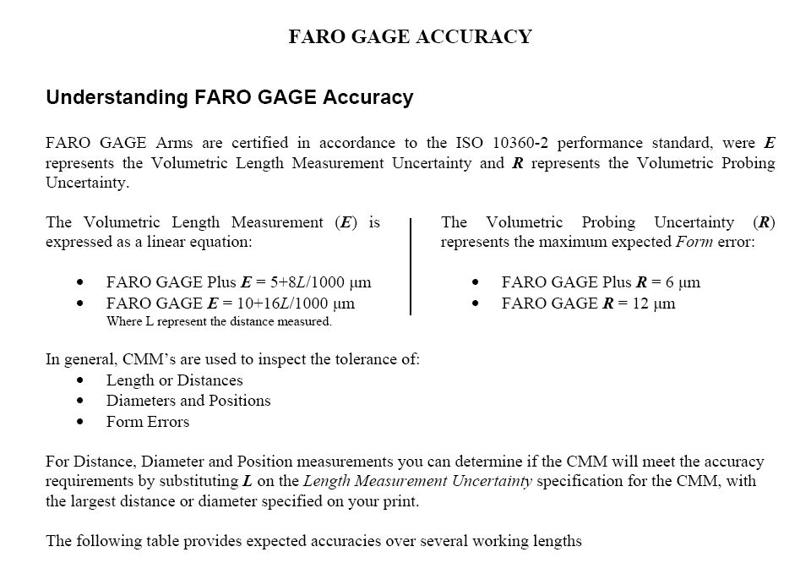

Accuracy Specification (mm)
Size (mm) | Gage Plus | Gage Standard
100 | 0.0058 | 0.0116
200 | 0.0066 | 0.0132
300 | 0.0074 | 0.0148
400 | 0.0082 | 0.0164
500 | 0.009 | 0.018
600 | 0.0098 | 0.0196
700 | 0.0106 | 0.0212
800 | 0.0114 | 0.0228
900 | 0.0122 | 0.0244
1000 | 0.013 | 0.026
1100 | 0.0138 | 0.0276
1200 | 0.0146 | 0.0292

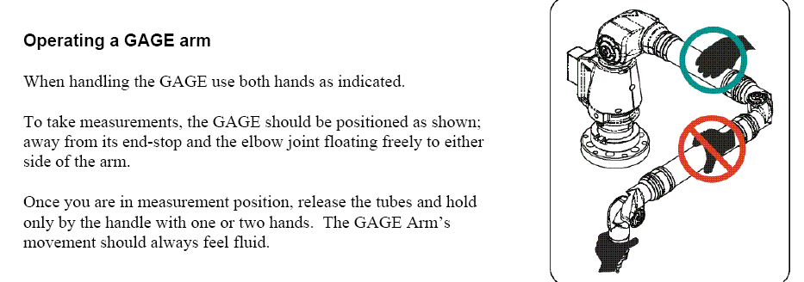

For questions and concerns please email FARO Customer Service at:
North America Europe Asia Pacific

250 Technology Park Lingwiesenstrasse 11/2 No. 3 Changi South Street 2
Lake Mary, FL 32746 70825 Korntal – Münchingen #01-01 Xilin Districentre Building B
USA Germany Singapore 486548
1.800.736.2771 +49.7150.97.97-400 1.800.511.1360
support@faro.com support@faroeurope.com supportAP@faro.com

Disclaimer: FARO Technologies, Inc. makes no warranty, express, implied or statutory, as to the material on this form, including any referenced third party. The material contained on this form is for informational purposes only; such material is provided “AS IS” and with all faults, and your use of the material is at your own risk.

