

Customer Service Department: *Fast* Fax

**To:** Faro Laser Tracker User **From:** Customer Service Department

6 Pages total including this page. Contact us immediately if pages are missing or not legible.

# Topic: Computer Ethernet Configuration for the FARO Laser Tracker in Windows 7

1. On the Windows Desktop, click on the Start menu, and do a search for “View Network Connections” and select it. Alternatively, you can go to Control Panel 🡪 Network and Internet 🡪 Network and Sharing Center and choose “Change adaptor settings” from the list on the left hand side.
2. There should be at least one ‘Local Area Connection’ icon. Use your mouse pointer to highlight each icon. The Tool Tip should state the make and model of the Network Adapter.

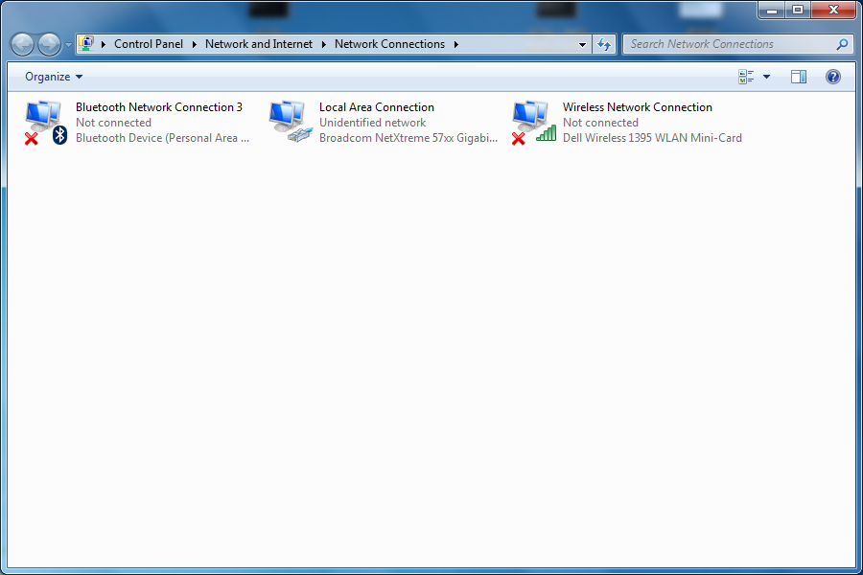

1. If there is more than one ‘Local Area Connection’ you will need to determine which one is the one being used for the FARO Laser Tracker system. Modern computers have a built in network connection. Some computers may have had another Ethernet board or Network Adaptor installed.
2. Right click on the ‘Local Area Connection’ icon that is being used for the tracker and select ‘Properties’.
3. Ensure that ‘Internet Protocol 4 (TCP/IPv4)’ has a check mark. Then select it and press the ‘Properties’ button.

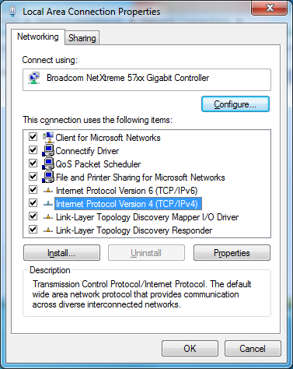

.

1. Select the ‘Use the following IP address’ radio button and add the following:

IP address: 128.128.128.X (where X is any number between 0 and 99)

Subnet mask: 255.255.255.0

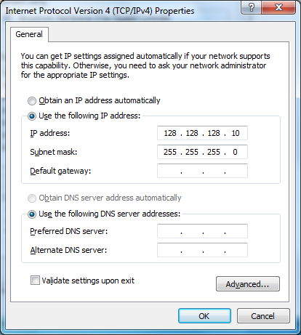

1. Now click the OK button to return to the ‘Local Area Connection Properties’ window.
2. Press Close to save these changes. You will be returned to the Network Connections screen.
3. Right click on the ‘Local Area Connection’ icon that is being used for the tracker and select ‘Properties’ a second time.
4. Select the Sharing tab at the top of the Properties window.
5. Ensure that “Allow other network users to connect through this computer’s Internet connection” is ***not*** selected. If it is, then remove the checkmark.

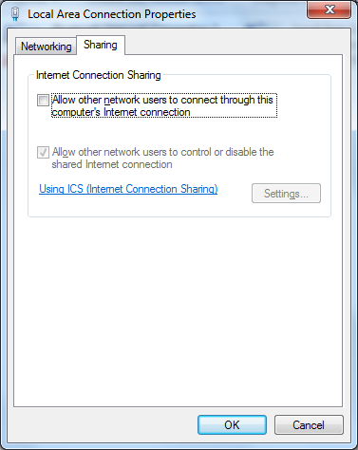

1. Press OK to save these changes. You will be returned to the Network Connections screen.
2. Close the Network Connections screen by selecting the ‘X’ in the upper right hand corner to return to the desktop.
3. On the Windows Desktop, click on the Start menu, and do a search for “Windows Firewall” and select it. (Do not choose Windows Firewall with Advanced Settings). Alternatively, you can go to Control Panel 🡪 System and Security 🡪 Windows Firewall.

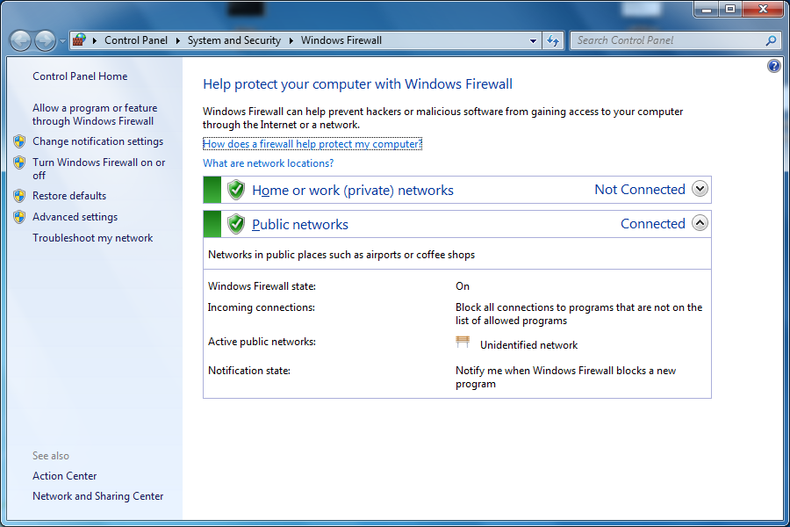

1. Select “Turn Windows Firewall on or off” from the left hand side.
2. Select “Turn off Windows Firewall (not recommended)” for both Private and Public network location settings.

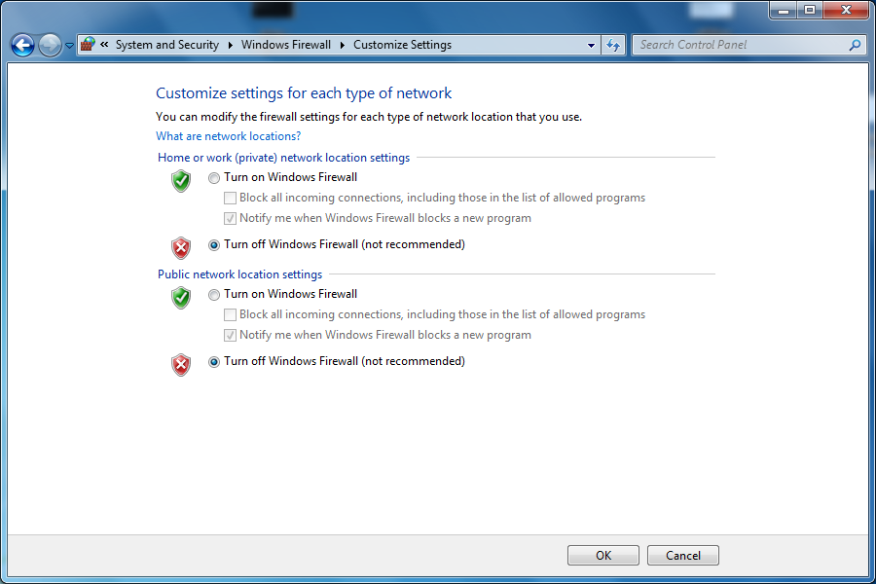

1. Press OK. A notification recommending that you Update you Firewall setting will be displayed. Do ***not*** press “Use recommended settings” or communication problems with the tracker will occur. If the computer is also connected to your corporate network using a second network adaptor or using wireless, there is still protection from the hardware firewall monitoring communications between the computer and the internet.

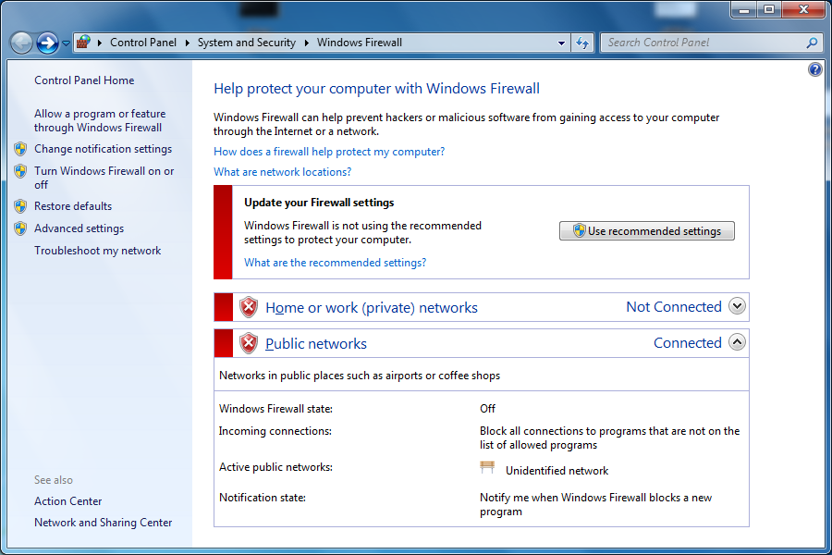

1. Close this screen by selecting the ‘X’ in the upper right corner to return to the desktop.
2. Ensure the Ethernet cable is connected to computer and the MCU. The connection on the MCU is next to the On/Off switch.
3. To verify that communication is present, from the Windows Desktop, click on the Start menu, and do a search for “cmd” and select it. A DOS prompt will open.
4. Type ‘ping 128.128.128.100’ and press Enter.

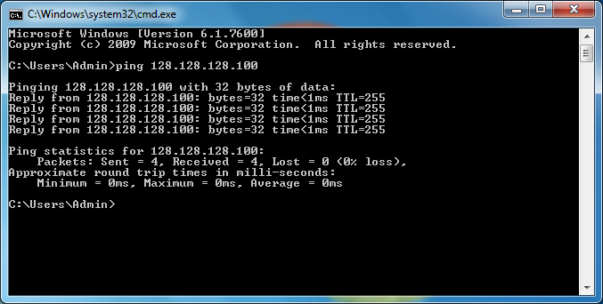

1. If you receive a “Reply”, then the computer and the Tracker are able to communicate with each other. If you received a “Request timed out”, then the computer and the tracker are not able to communicate with each other. Possible causes are:

* The tracker is not connected to the computer or the Ethernet cable is not working properly.
* The tracker is not turned on.
* ‘Local Area Connection’ (or the network adaptor that was just configured) is Disabled.
  + To Enable it, go back to “View Network Connections”, select it, right click and choose Enable
* ‘Local Area Connection’ is not the network adaptor that the tracker is connected to (this applies if there are multiple network connections on the computer)
* Someone has changed the trackers IP address from its default of 128.128.128.100 and a ‘Local Area Connection’ needs to be assigned a different IP address than the one described in Step 6. This IP address would need to be compatible with trackers new IP address that it was manually configured with.

1. Close the DOS prompt by selecting the ‘X’ in the upper right corner to return to the desktop.

If problems connecting to the tracker persist, the inspection software (such as CAM2) may not be configured to communicate with the tracker correctly or there may be 3rd party firewall software installed on the computer that needs to be disabled.

If you are still experiencing difficulties, please contact the customer service department by telephone at **1-800-736-2771** or by e-mail at [**support@faro.com**](mailto:support@faro.com)

**Be sure to visit our website at** [**faro.com**](http://www.faro.com/)

FAX questions to: (407) 333-8056